CHAPTER FIVE

DISCUSSION

  - Introduction

This chapter analyses the results presented in chapter 4. As indicated in chapter 1, the motivation behind this project was to continue the investigation into the adsorption of aurocyanide onto HOPG, that was started by G. Kirton in his Honours project, and extended by Dr G. Poinen in his doctoral thesis.

In this earlier work, it had been shown that the STM could be successfully used to image features on HOPG in situ. It was believed that these features were deposits of gold-based material adsorbed onto the HOPG from the potassium aurocyanide solution. It was also found that these deposits were extremely rare unless calcium ions were present in the solution. ⁽²⁾ Even with the presence of calcium ions, the deposits were not widespread, and were found only in close proximity to step edges and other defects in the HOPG surface.

From this evidence, Dr Poinen proposed that the calcium ions were intercalating between the graphite layers of the HOPG at these defect sites, and then gold, in the form of aurocyanide, was attracted to these sites where it was adsorbed.

This proposal was challenged by a number of other researchers. The principle objections raised were, that there was no direct evidence of the intercalation of calcium, and that there was no direct evidence that the features imaged were actually gold-based deposits. It was hoped that in using STS, it would be possible to identify the composition of the features, and so determine the validity of Dr Poinen’s proposal and that of the objections.

  - Conductance Spectroscopy

The experiments undertaken using the conductance spectroscopy technique outlined in section 3.5 of chapter 3, showed that, with care, some features were clearly due to a change in the composition of the surface. This was evident in figure (4.3), reproduced below as figure (5.1)

For this image, the HOPG had been covered by a solution of KAu(CN)₂ and CaCl₂ for about 29 hours. As can be seen in the topographical image on the left, the HOPG surface was quite buckled in this region. There were also some regions that had the appearance of deposits.

Figure 5.1
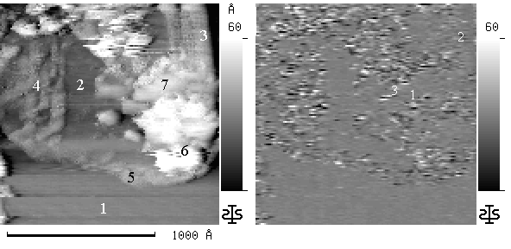
dI/dV conductance image of HOPG under solution of KAu(CN)₂ and CaCl₂

Near the bottom of the topographical image is a region of flat, undeformed HOPG, (region 1). This region shows up as a uniform grey in the conductance image on the right. There is also a region of flat HOPG just left of centre, (region 2). This area is also a uniform grey in the conductance image. In the upper right, there is a raised region. (3). In the conductance image this region is also a relatively uniform grey. This indicates that the region is simply buckled HOPG.

On the left (4), and on the top edge of region (1), (5), there are raised features with corresponding features in the conductance image. However, as discussed in chapter 4, (section 4.1) a change in topography can generate a spectroscopic feature as the tip changes height. Therefore, it cannot be determined if the regions are a change in surface composition or just buckled HOPG.

Region (6) is a very high region. The upper portion of this region in the conductance image is the uniform grey of HOPG. However the lower portion is very different. This would indicate that the lower portion is not HOPG. Similarly in region (7), the lower portion shows the grey of HOPG while the upper portion shows features in the conductance image, despite being of similar height. Again this would indicate it is composed of something other than HOPG.

Other images presented in chapter 4 also show clearly that some features are not HOPG. Image 4.8, here reproduced as figure 5.2, is one such example. In this instance, the HOPG had been covered by a solution of KAu(CN)₂ and CaCl₂ for about 26 hours. The spectroscopy image was derived from current variation with tip-surface variation. (dI/dZ)

Figure 5.2
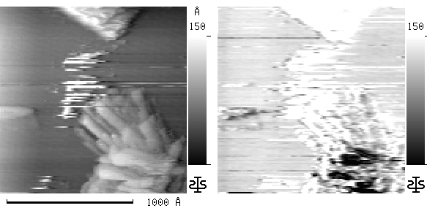
dI/dZ conductance image of HOPG under solution of KAu(CN)₂ and CaCl₂

Near the top of the image there is a piece of HOPG that has folded back. This region shows up as white in the spectroscopy image. In the lower right quadrant, there is a large feature that shows as dark in the spectroscopy image. This difference shows clearly that the feature is not composed of carbon. Rather it must be a deposit of some material from the solution. However, as mentioned in chapter 4, this form of spectroscopy does not allow an unambiguous identification of the composition of the material. Still, by showing that some of the features are not simply carbon, the technique has answered one of the objections raised against the hypothesis put forward by Dr Poinen.

5.3 I/V Spectroscopy

    - Test materials

A theoretical examination of a density of states convolution between various materials and platinum was presented in chapter 2, (section 2.4). This examination was performed to investigate the possibility of using I/V spectroscopy to identify surface materials. This investigation indicated that even with the restricted voltage range available for in situ I/V spectroscopy, the technique could distinguish between different classes of materials such as semi-conductors and noble metals. This conclusion was verified in experiments made using a variety of materials, as shown in the results presented in chapter 4, (section 4.2).

These results show clear differences between each of the 3 semi-conductors, silicon, carbon (HOPG) and galena (PbS). There were also clear differences between the semi-conductors and the noble metals, gold, silver and platinum. These differences were easily seen in the I/V spectra so there was no need to convert the spectra to the normalized derivative form.

Slight differences could be seen between the 3 noble metals, however the differences were so small that it would be very difficult to distinguish these elements by their I/V spectra, especially considering that each individual spectrum was somewhat variable. The spectrum of the transition element copper was however, very different.

The I/V graphs for carbon (HOPG) and gold are reproduced in figure (5.3) to illustrate the differences.
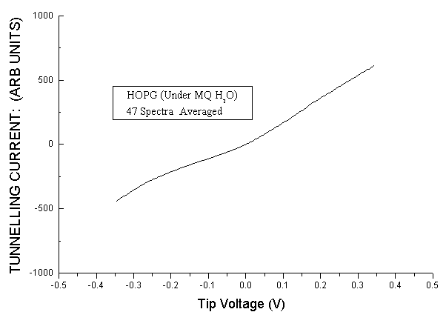
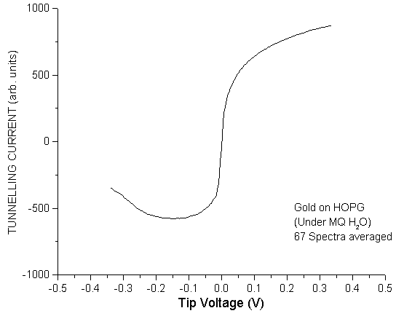
Figure 5.3a Figure 5.3b
I/V spectrum of HOPG I/V spectrum of Gold

As can be seen in the two graphs, the spectra are very different and easy to tell apart.

All of the materials were examined in air and under liquid to see if the liquid would have any effects on the spectra. The results presented in section 4.2 of chapter 4, clearly show the any differences are minimal and do not affect the identification of the various classes of materials. Therefore the technique works equally well in liquid as in air. It was however, found that when working under water-based solutions, it was necessary to limit the voltage range to ± 0.5V. Operating over a larger range resulted in electrochemical reactions between the tip and the solution, with bubbles of gas forming at the tip. The wax coating of the tip also broke down very quickly resulting in the tip rapidly becoming unusable.

    - Potassium aurocyanide on HOPG

Once spectra were obtained from material deposited from a solution of KAu(CN)₂ and CaCl₂, it was immediately obvious that the material was gold-based. This is illustrated in figure (4.42), reproduced below as figure (5.4). This image shows a section of HOPG that is partly covered by a deposit. Spectra taken from the deposit and from the HOPG are shown with the image.

Figure 5.4
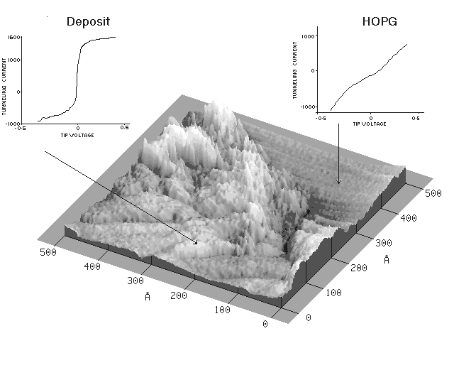
Image of HOPG partly covered by a deposit.
Spectra of the deposit and the HOPG are also shown

The two spectra are clearly different. The HOPG spectrum closely resembles the carbon spectrum taken on the clean HOPG, shown in figure (5.3a), while the deposit spectrum is similar to the gold spectrum in figure (5.3b). This clearly shows that the material is gold-based. However there are some differences between the gold spectrum and the deposit spectrum. Figure (5.5a) is the averaged spectrum of gold taken under ultra-pure water, while figure (5.5b) is the averaged spectrum for the deposit.
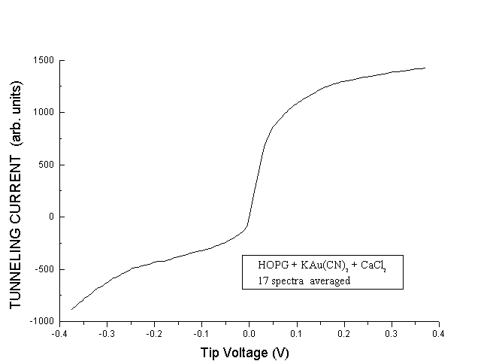

Figure 5.5a Figure 5.5b
Spectrum of gold on HOPG Spectrum of deposit.
taken under ultra-pure water.

Comparing the two graphs, it can be seen that at positive tip bias, the two spectra are almost identical. However at negative tip bias, the gold spectrum goes to a minimum and then turns upward, while the spectrum for the deposit always slopes downward. In fact, at the negative tip bias, the deposit spectrum looks somewhat like the HOPG spectrum of figure (5.3a). This indicates that the material deposited on the HOPG has a different density of states below the Fermi level, and is therefore not metallic gold.

There are a number of possible reasons why this could be. One reason is that at negative tip bias, the tip is “seeing” the HOPG substrate. However, this is unlikely as the experiments on gold deposited on two different substrates (HOPG and aluminium) yielded the same spectra. (figures 4.26 and 4.28).

Another reason could be that the material had chemically bonded to the HOPG surface. However, as shown in figure (4.37), it was possible to remove the deposit on some occasions. This shows that the material was only very weakly attached to the surface. This means a physical bonding rather than a chemical bonding.

A third possible reason is that the material deposited was not pure gold, but rather a gold salt. As mentioned in chapter 1 (section 1.4), a variety of forms of gold have been proposed for the adsorbed species. These include Au, AuCN, Au(CN)₂⁻, [Ca²⁺Au(CN)₂⁻]⁺, and Ca[Au(CN)₂]₂.

From the spectra presented above, gold in the form of metallic gold can be ruled out. Previous work in this laboratory supports this conclusion. [Ca²⁺Au(CN)₂⁻]⁺ is also unlikely as the candidate, since the adsorption of a positive ion such as this, would have occurred in a relatively short time. This is contrary to the observed situation in this project, where the adsorption did not occur in less than 24 hours.

Figure (5.6a) and figure (5.6b) reproduce the spectrum for AuCN deposits on HOPG presented in section 4.3.3.2 of chapter 4.
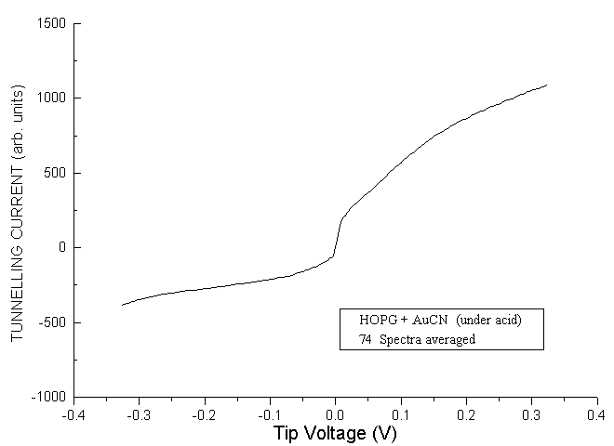

Figure 5.6a Figure 5.6b
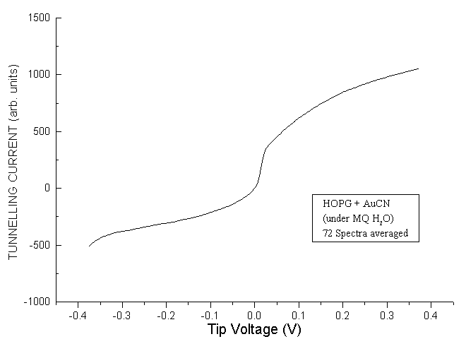
Spectrum of AuCN on HOPG Spectrum of AuCN on HOPG
taken under ultra-pure water. taken under weak HNO₃

A comparison of these two graphs with figure (5.5b) shows that the graphs are broadly similar. However there are some differences. The AuCN graphs do not show such a steep rise near 0V tip bias, nor do they level off as much at increasing positive tip bias. This shows that the deposits are not neutral AuCN.

However the spectra are sufficiently similar to indicate that aurocyanide forms the basis of the deposits. This is in harmony with the model proposed by Dr Poinen that the calcium ions intercalate between the graphite sheets of the HOPG. Then the aurocyanide is attracted to these sites where it is adsorbed in the form of M^{n+} - C – [Au(CN)₂⁻]_{n}, where M is the calcium ion. This model is further supported by the fact that only once was any evidence of calcium observed in the spectra, despite repeated searches. The one time that a possible calcium spectrum was observed was on some HOPG that had been covered by a solution of CaCl₂ for 46 hours and the solution was partly evaporated. In one location a small deposit was found of material was found. This was considered to be some CaCl₂ that had precipitated out as the solution evaporated. Since at no other instance was any calcium spectra observed, it indicates that any calcium must have been below the surface. Theoretical modelling conducted at this laboratory has also provided further support for calcium intercalation as the key to aurocyanide adsorption onto HOPG.

    - Potassium aurocyanide on activated carbon

In his doctoral thesis, Dr Poinen stated that he considered the adsorption mechanism for HOPG to be different from that of activated carbon. However time constraints prevented him from pursuing an investigation into the adsorption onto activated carbon.

The spectrum of dry activated carbon was displayed in figure (4.48). When this graph is compared with that of HOPG, shown in figure (5.3a), it can be seen that there are some differences. There is no band gap for the activated carbon, and the graph has an almost constant slope except when the negative tip bias is more than –0.2V. This indicates that the surface of the activated carbon is not pure carbon. The impurities could either be functional groups or contaminants not removed in the cleaning process in chapter 3. In this regard, the activated carbon would be similar to that used in gold processing.

Some difficulty was experienced in locating deposits on the activated carbon, as the roughness of the surface necessitated small scan sizes. Of interest was that the deposits on the HOPG had a tendency to occur in elongated and approximately parallel patches near surface defects. Yet the deposits on the activated carbon tended to occur in scattered lumps. Figure (5.7) is an example of the deposits found on the HOPG, while figures (5.8) and (5.9) are examples of deposits on the activated carbon.
Figure 5.7
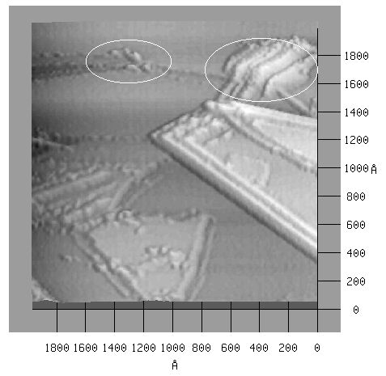
Aurocyanide deposits on HOPG
Figure 5.8
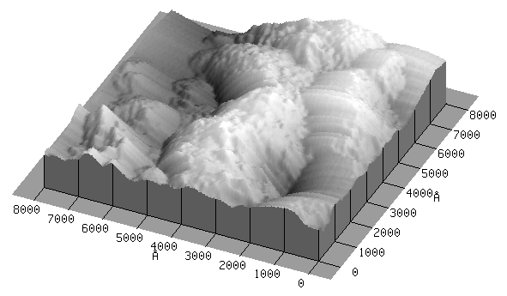
Aurocyanide deposits on activated carbon
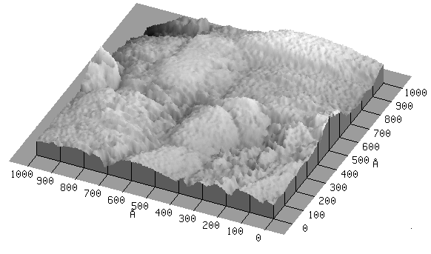
Figure 5.9
Aurocyanide deposits on activated carbon

This difference is most likely the result of the rough surface of the activated carbon compared to the very flat surface of the HOPG. On the HOPG, the calcium most readily intercalates the carbon at defect edges, attracting the aurocyanide to these locations. However the activated carbon is so rough that it would be possible for the calcium to intercalate almost anywhere, if in fact this is the mechanism by which adsorption occurs. This would allow for a more random adsorption. However it may also indicate a different adsorption method as indicated earlier.

As with the HOPG, it was very easy to distinguish between the activated carbon and aurocyanide deposits by their spectra. This was illustrated by figure (4.49) where the difference between the two spectra is obvious. The averaged I/V spectrum of the aurocyanide deposits is reproduced from chapter 4 as figure (5.10).
Figure 5.10
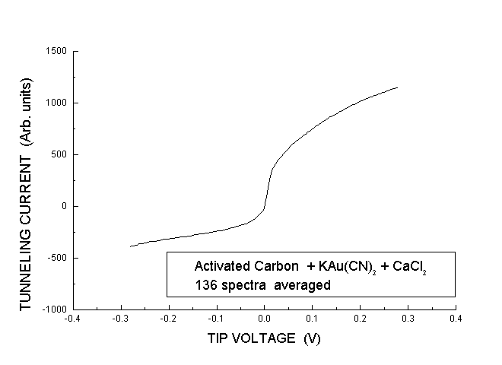
Aurocyanide deposits on activated carbon

Comparing this graph with the other aurocyanide graphs in figures (5.5b), (5.6a) and (5.6b) is interesting. The graph shows some differences to the spectrum of aurocyanide adsorbed onto HOPG. There is a smaller rise around 0V tip bias, and the slope is different for negative tip bias. The graph is more similar to the AuCN graphs. However there are still some small differences. There is a steeper rise around 0V, and the slope is different at positive tip bias voltages. The next graph, figure (5.11), shows the differences more easily. In this graph, the spectra of AuCN under ultra-pure water, and of aurocyanide deposit on activated carbon, and aurocyanide deposits on HOPG, are superimposed.
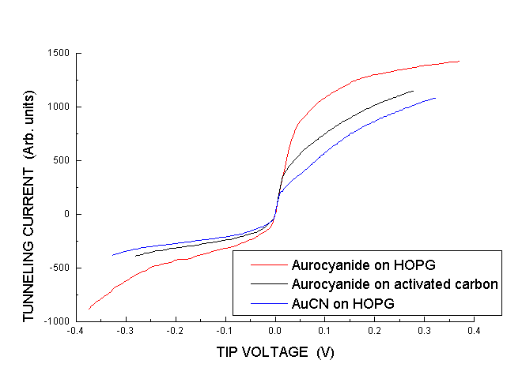
Figure 5.11
Superimposed spectra of aurocyanide deposits on HOPG, aurocyanide deposits on activated carbon, and AuCN on HOPG under ultra-pure water,

As can be seen in this graph, the spectrum for the aurocyanide on activated carbon is between the other two spectra. This would indicate that the adsorption mechanism is different for the activated carbon. In a study of aurocyanide adsorption on activated carbon, Adams and Fleming concluded that the adsorption mechanism under alkaline conditions commonly found in plant conditions, was in the form of an ion pair of the type M^{n+} [Au(CN)₂]^{n-}.

However there is a problem. Although the spectrum of the adsorbed species is between the other two spectra, it is very similar to the AuCN spectrum. This would indicate that the adsorbed species is more closely related to AuCN. This is an unexpected result. It was expected that the spectrum would more closely resemble the aurocyanide ion spectrum. There are two possible explanations. Either the calcium-aurocyanide ion pair spectrum is very similar to the AuCN spectrum, or, in this case, the adsorbed species is AuCN.

A strong argument against AuCN as being the species adsorbed onto activated carbon in the CIP process is that the adsorption is a readily reversible process. However AuCN is insoluble in aqueous solution. Also, in the CIP process, the adsorbed aurocyanide is totally removed from the activated carbon by hot NaOH. However under these conditions, AuCN is reduced to gold metal. Therefore AuCN was not expected on the carbon. Unfortunately, there was insufficient time available to undertake any theoretical investigation into the spectrum of the calcium-aurocyanide ion pair. However it would not be expected to be almost identical with the spectrum of AuCN.

There is another possibility. Under acidic conditions, Au(CN)₂⁻ reduces to AuCN via the following reaction;

Au(CN)₂⁻ + H⁺ → AuCN (↓) + HCN (↑) (5.1)

This was the method used to deposit AuCN on HOPG for the AuCN experiments.

As mentioned earlier, dilute nitric acid was used in an attempt to remove contaminants from the activated carbon. Although the activated carbon was washed in a large volume of ultra-pure water for some considerable time following the acid treatment, it is possible that some acid remained on the surface of the carbon, particularly deep in the micropores. If this did happen, then it is possible that the above reaction occurred, giving rise to the AuCN on the surface. Attempts were made to repeat the experiment using totally untreated activated carbon, however the STM head had developed problems which could not be rectified in time.

Although it proved to be not possible to check this explanation, it is considered that it is still the most likely explanation for the spectra.

