Chapter 4

RESULTS

  - INTRODUCTION
In this chapter, the results of the experiments are presented. The first section (4.2) deals with the results obtained from experiments on potassium aurocyanide adsorption onto HOPG, using the local conductance method discussed in section 3.5 of chapter 3.

The rest of the chapter deals with the results obtained using the I/V spectroscopy method. Firstly, the results of experiments on semi-conductors are presented. (section 4.3.1) These are followed by the results of experiments on metals. (section 4.3.2) Section 4.3.3.1 presents the results of experiments on potassium aurocyanide solution on HOPG, while section 4.3.3.2 presents the results of experiments on AuCN deposited on HOPG.
Finally, in section 4.3.4, the results of experiments made using activated carbon as the base instead of HOPG, are presented.

4.2 CONDUCTANCE SPECTROSCOPY

Initial attempts to investigate the nature of deposits on HOPG under gold-bearing solution were made using the conductance techniques of scanning tunneling spectroscopy discussed in Section 2.2 of chapter 2.

Samples of HOPG, covered by several drops of KAu(CN)₂ and CaCl₂ solutions, were prepared as described in chapter 3. After allowing time for deposition to occur (between 28 and 42 hours) the sample was placed in the STM and a search was made for any signs of deposits by taking large-scale images in mode 1. Generally deposits were only found in close proximity to step edges or other surface deformations. This was in accord with previous work undertaken at Murdoch, as discussed in chapter 3. A number of experiments were also conducted using only KAu(CN)₂ solution. In these experiments, virtually no deposition was observed, again in accordance with previous work undertaken at Murdoch. Once a deposit was located, the STM was switched to mode 4 and more detailed, smaller scale images were taken.

Figure (4.1) shows an image taken using local conductance (dI/dV). The image at left is the usual topographic image, while the image on the right is a map of the local conductivity.
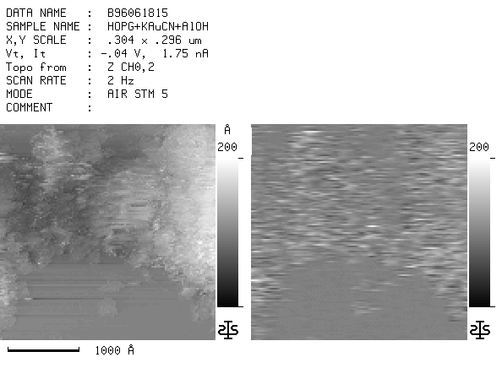
Figure 4.1
Local conductivity (dI/dV) image of deposit on HOPG under a solution of KAu(CN)₂ and CaCl₂

As can be seen, near the bottom of the images, where flat carbon is visible in the topographic image, the conductivity image is also flat and uniform. However where the topographic image shows features, the conductivity image also shows changes. The difficulty in interpreting such conductivity features lies in deciding which features are topographically induced and which are due to compositional differences. Topographically induced features are illustrated in figures (4.2) and (4.3) shown on the next page.

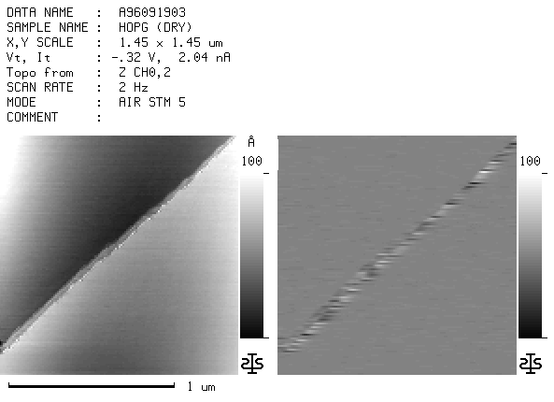
Figure 4.2
Local conductivity (dI/dV) image of HOPG in air.

Figure (4.2) shows an image of dry, freshly cleaved HOPG in air with a step running diagonally from lower left to upper right. As can be seen, the step causes a feature in the conductivity image on the right.

In figure (4.3), the regions marked (1) and (2) show the same conductivity as the carbon region at the bottom of the images, yet they are clearly higher. This would indicate that these areas are simply regions where the carbon layers have buckled. Note however region (3). This shows a different conductivity to the other two regions even though it is of similar height to region (1). This indicates that it is not carbon, but rather a deposit of some different substance.

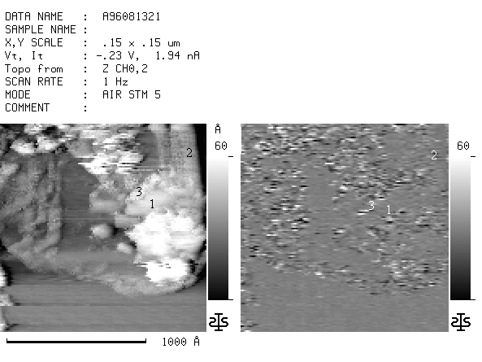
Figure 4.3
Local conductivity (dI/dV) image of deposit on HOPG under a solution of KAu(CN)₂ and CaCl₂

Unfortunately, in many images, it is very difficult to glean any meaningful information. Figure (4.1), here reproduced as Figure (4.4), is an example of this. In this image, the surface is very rough with areas of buckled carbon, broken flecks of carbon and possible deposits. Here it is almost impossible to sort out which features in the conductivity image are due to topographic changes and which are due to chemical species differences.

Figure 4.4
Local conductivity (dI/dV) image of deposit on HOPG under a solution of KAu(CN)₂ and CaCl₂

These examples indicate how difficult it can be to separate topographical and electronic features. Also, even when it is possible to determine the existence of a deposit, very little information is gained about the nature of the deposit.

One interesting set of data was the following group of images of HOPG, which had been covered by a solution of KAu(CN)₂ and CaCl₂ for 23 hours. Figure (4.5) is a large-scale image that shows a step running from the middle left to the bottom right. A few brighter spots are visible along the step in the topographic image, but little can be distinguished in the conductivity image due to the large scale.
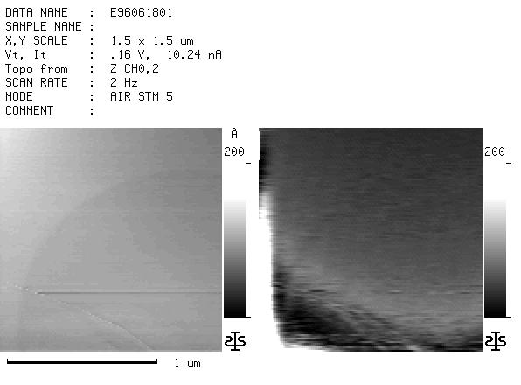
Figure 4.5
Local conductivity (dI/dV) image of HOPG under a solution of KAu(CN)₂ and CaCl₂ .
Note the bright spots on the step edge in the topographic image on the left.

Figure (4.6) is a smaller scale image centred on the step. The bright spots are easily distinguished along the step and show up in the conductivity image as dark regions. The reason the bright spots show up as dark regions in these conductivity images rather than bright as in previous images, is that for these images the bias voltage was positive whereas before it was negative.

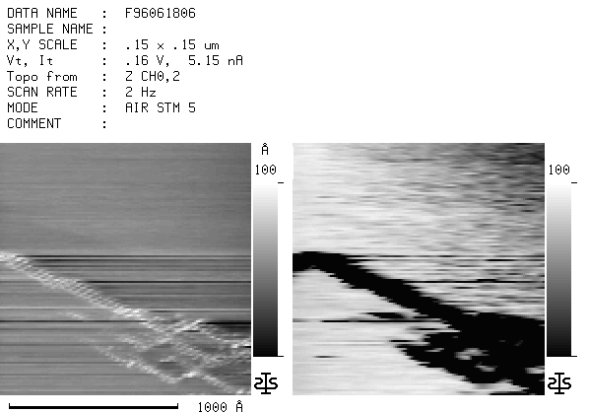
Figure 4.6
Local conductivity (dI/dV) image of deposit on HOPG under a solution of KAu(CN)₂ and CaCl₂

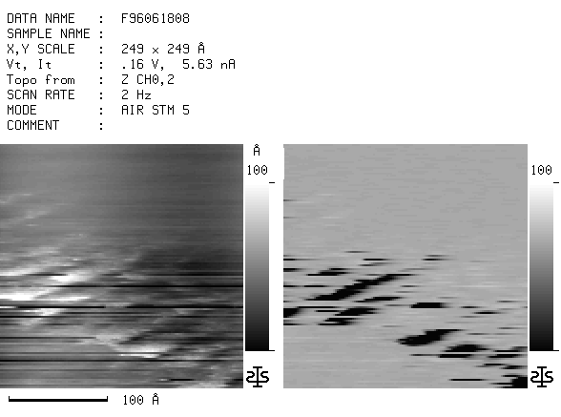
A further close-up image of the feature is shown in figure (4.7).
Figure (4.7)
Local conductivity (dI/dV) image of deposit on HOPG under a solution of KAu(CN)₂ and CaCl₂

Interesting though they are, it is not clear from these images whether the features are simply deformations in the HOPG, or a deposit of some material, even though the most likely explanation is a deposit. Also it is not possible to determine the nature of the material, if it is a deposit.
This situation is a little clearer in the next set of images. Again these are of HOPG that has been under a solution of KAu(CN)₂ and CaCl₂ for 24 hours. In the first image, figure (4.8), at the centre left and the top centre, there are flakes of loose HOPG. These show very little difference from the base HOPG in the conductivity image. The main difference is that they tend to be a little brighter, as in the previous conductivity images taken at negative bias. However at the lower right there is another feature (shown in more detail in figure (4.9) which shows up very dark in the conductivity image. The fact that the feature is dark in the conductivity image shows that it cannot be just disturbed HOPG. Rather it must be a deposit of some kind. Unfortunately, the composition of the deposit cannot be determined.
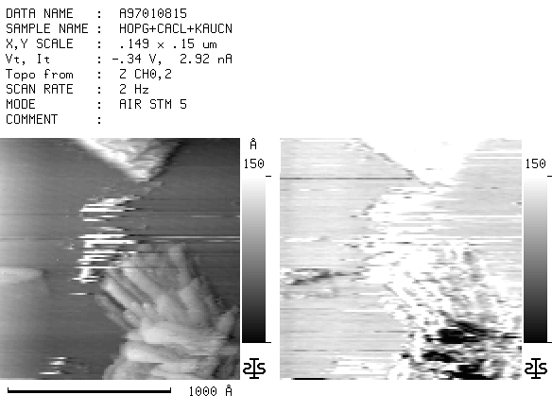
Figure (4.8)
Local conductivity (dI/dZ) image of deposit on HOPG under a solution of KAu(CN)₂ and CaCl₂
Figure (4.9)
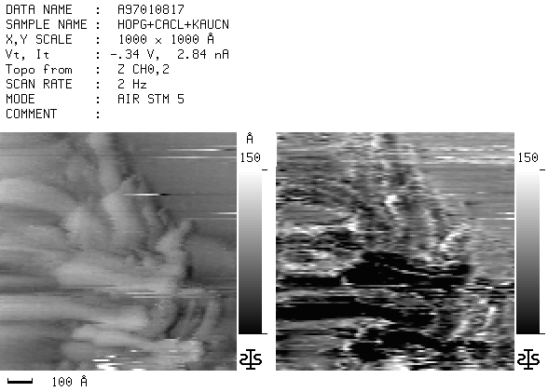
Local conductivity (dI/dZ) image of deposit on HOPG under a solution of KAu(CN)₂ and CaCl₂

4.3 I/V and dI/dV SpectrOSCOPY

In view of the inability of the conductance spectroscopy to unambiguously identify the adsorbed species, it was decided to investigate the use of point spectroscopy as a tool for identifying the adsorbed species. In order to see if the technique would work under liquid, several elements were examined, firstly in air and then under liquid to establish a baseline of distinguishing features.

    - SEMI-CONDUCTORS

4.3.1.1 Silicon

The first element examined was silicon. Silicon was chosen as the first substance because silicon had been examined with STS before and this data would provide a comparison for the data obtained during these experiments. This was considered particularly important for the experiments conducted under liquid as it was not known if the liquid would have any effect on the spectra.

As described previously in chapter 3, “p-type” silicon was used for these experiments. However, since the experiments were conducted in air, the surface would have been coated with oxide. This means that the surface actually studied was silicon dioxide. In the imaging, no atomic resolution was achieved, nor was any expected due to the amorphous nature of the surface. A large number of images were taken along with numerous spectra. The averaged I/V spectra of the dry silicon are shown in figure (4.10)
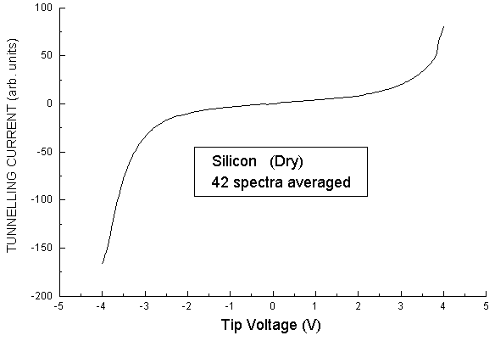
Figure 4.10
I/V spectrum of oxidized silicon in air

Following the experiments conducted in air, the sample was covered with several drops of diffusion pump oil to examine the effects of imaging and conducting STS under liquid.

Again a large number of images were taken along with numerous spectra. Figure (4.11) shows the resulting I/V spectra averaged.

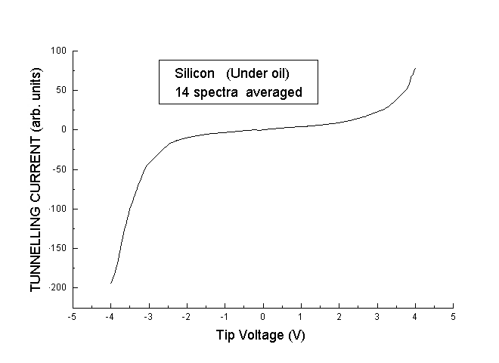
Figure 4.11
I/V spectrum of oxidized silicon in liquid

The I/V spectra reveal little information other than the band gap where the current is zero. More information can be obtained by plotting the normalized derivative of I/V as discussed in chapter 2.

Figures (4.12) and (4.13) on the next page, show the normalized derivative (dI/dV) spectra obtained from the silicon sample. Figure (4.12) is the averaged spectrum of the surface in air, while figure (4.13) is the averaged spectrum with the surface covered with diffusion pump oil.

Figure 4.12
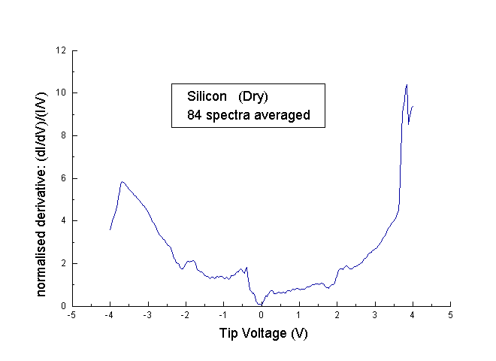
dI/dV spectrum of oxidized silicon in air
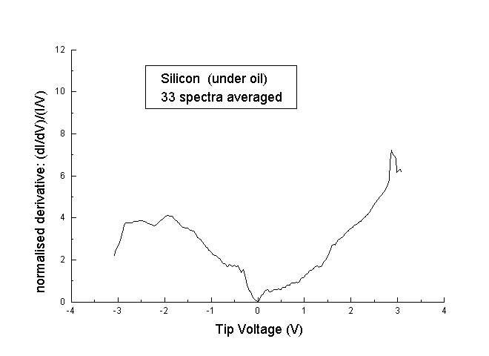
Figure (4.13)
dI/dV spectrum of oxidized silicon covered with diffusion pump oil

The two spectra are generally similar, with both showing a band gap around 0V and peaks at about -1.8V, -0.5V, and +0.25V. However there are 2 noticeable differences. Firstly the graph for the dry sample is lower for much of the range while on the positive side, the peaks at 1.6V and 2.3V appear to be displaced to slightly lower values in the sample covered with oil. The peak at the positive end of both graphs is an artifact of the spectrum calculation, as is the drop at the negative end.

Shown below as figure (4.14), is a dI/dV spectra obtained from silicon that was exposed to a controlled amount of oxygen while under ultra-high vacuum conditions.⁽²⁾ Several of the features are noted. E_{VSi} and E_{Csi,} are the top of the valence band and the bottom of the conductance band respectively for bulk silicon, while E_{Vox} and E_{Cox} indicate the same features for SiO₂.
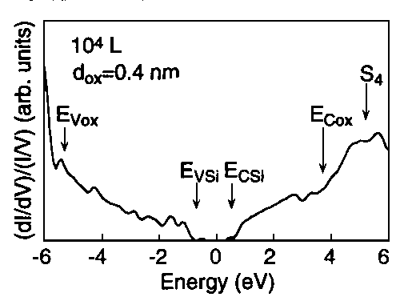
Figure (4.14)
dI/dV spectrum of oxidized silicon. From Ref (2)
Comparing this spectrum with figures, (4.12) and (4.13) the overall shape is similar although some of the features in figure (4.14) are slightly different. For example, the band gap around 0V is much wider, and the dip, which in figure (4.12) is at about +1.8V, is at around +2.8V in figure (4.14). However the peak at -1.8V appears at the same value. The most likely explanation for these differences is that in figure (4.14), the oxide layer is very thin and formed in controlled conditions. This allows the bulk silicon to still feature strongly, whereas in the other two graphs, the oxide layer is thick, and formed in moist conditions. This masks the bulk silicon to a greater extent. The narrowing of the band gap indicates that surface states are trailing into the band gap. The differences at positive tip bias would indicate that the thick oxide layer has most effect on electrons tunneling from the sample.

Despite these differences, the general overall similarity indicates that the technique can yield useful data, both in air and in liquid.
4.3.1.2 Carbon
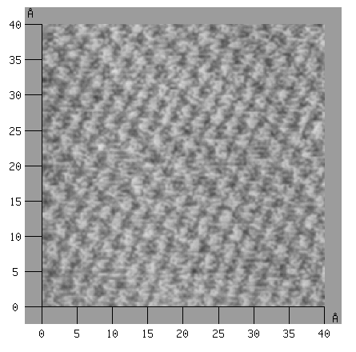
Following the success with the silicon samples, carbon, in the form of HOPG was next examined. Atomic resolution was readily obtained in both air and under water. Examples of these are shown below in figures, (4.15)(air), and (4.16)(under water). Surprisingly, it was found that atomic resolution was achievable much more readily under water than in air. A similar situation was found later when a gold (111) crystal was examined.
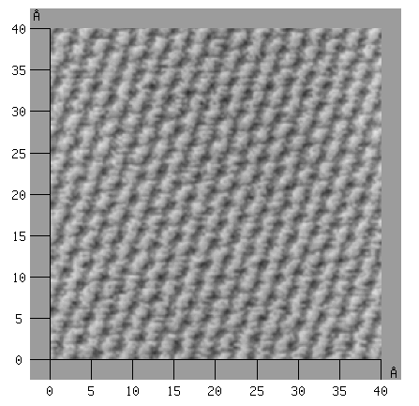
Figure 4.15
Image of HOPG in air showing atomic resolution
Figure 4.16
Image of HOPG under water showing atomic resolution
Figure (4.17) shows the I/V spectrum of HOPG in air while figure (4.18) shows the I/V spectrum for HOPG under water. As can be seen, the two graphs are very similar.
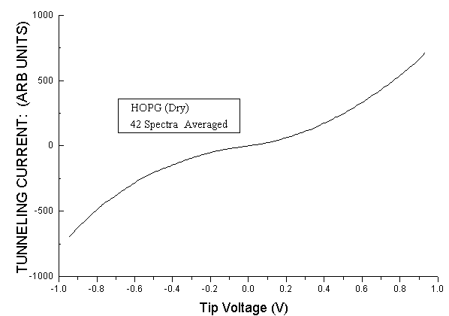
Figure 4.17
I/V spectrum of HOPG in air.
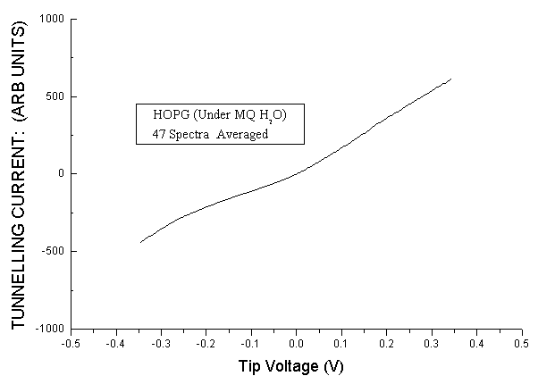
Figure 4.18
I/V spectrum of HOPG under water

As with the silicon I/V spectra, not much can be discerned from the spectra. Therefore they are shown as normalized derivatives in figures (4.19) and (4.20).
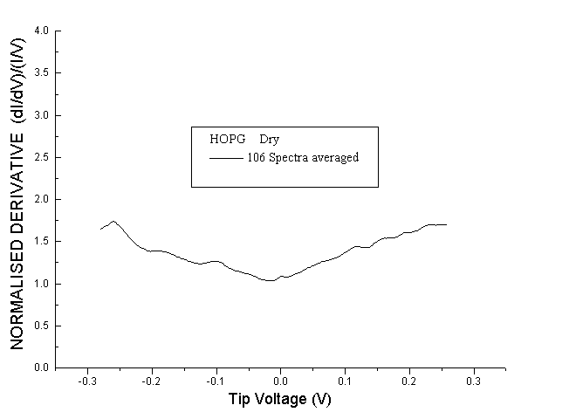
Figure 4.19
dI/dV spectrum of HOPG in air
Figure 4.20
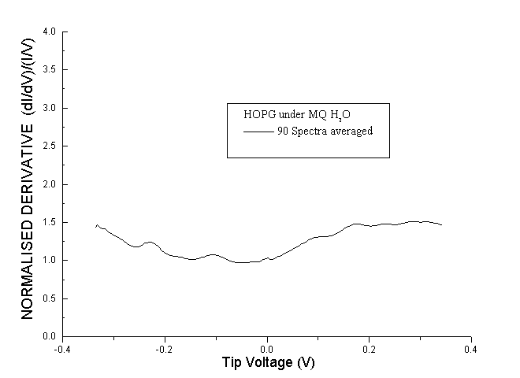
dI/dV spectrum of HOPG under water

The spectra appear almost featureless over this small range, which is what was expected from the convolutions discussed in chapter 3. However there are several small features visible. There are small peaks at –0.2V and –0.1V in both spectra, and another small peak at +0.1V. That these features are noticeable in both spectra, illustrates that covering the surface with water does not interfere with the spectroscopy. Also there is no clear band-gap such as appeared in the silicon spectra.

      - Galena
The third semi-conductor examined was the compound semi-conductor, lead sulphide, also known as galena. The principle interest in this semi-conductor was whether or not the STS would show the spectra of the individual elements or that of the compound. The spectrum obtained is shown in figure (4.21).
Figure 4.21
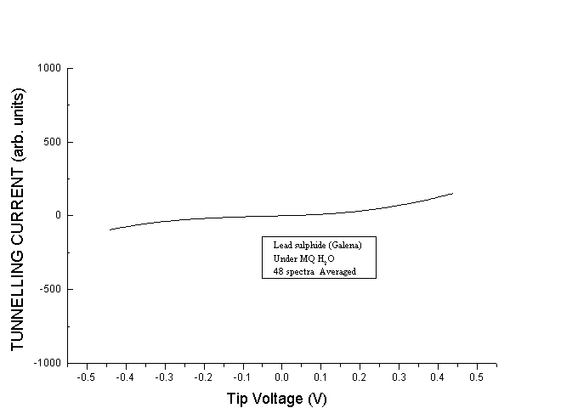
I/V spectrum of lead sulphide under water
As can be seen, the spectrum is clearly that of a semi-conductor with the flat region around 0 tunnelling current indicating a band gap. The main difference between the galena and the other two semi-conductors, is the very small range over which the tunnelling current varies. In the galena it is much smaller.

    - METALS

4.3.2.1 Gold

Attention was now turned to the metals with gold being the first metal examined. After partially covering a piece of HOPG with a thin layer of gold as described in chapter 3, the surface was imaged with the STM, firstly in air. Figure (4.23) is an example of the resulting images.

Figure 4.23
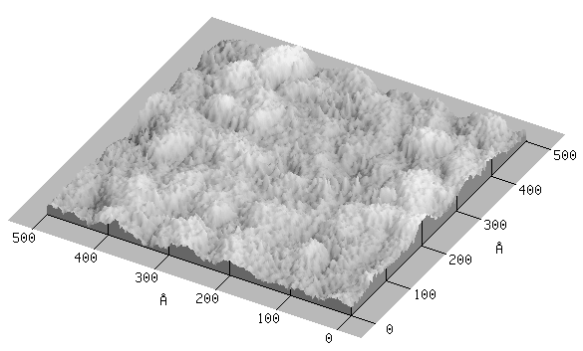
Image of gold deposited on HOPG. Taken in air

After taking a large number of images and spectra, the I/V spectra were averaged and also converted into normalized derivative spectra. These spectra are shown in figures (4.24) and (4.25). The process was then repeated with several drops of ultra-pure water covering the gold. These spectra are shown in figures (4.26) and (4.27)
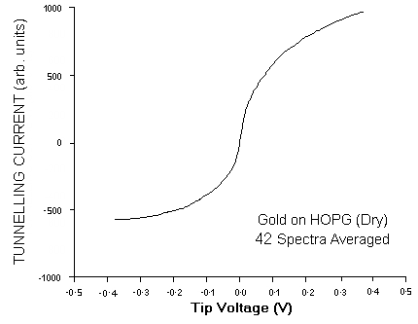
Figure 4.24
I/V spectrum of gold deposited on HOPG. Taken in air.

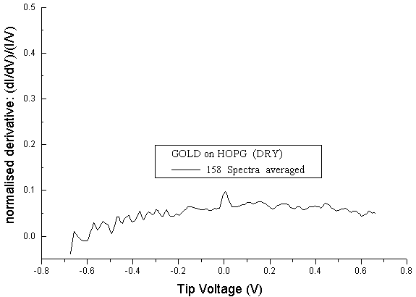
Figure 4.25
dI/dV spectrum of gold deposited on HOPG. Taken in air
Figure 4.26
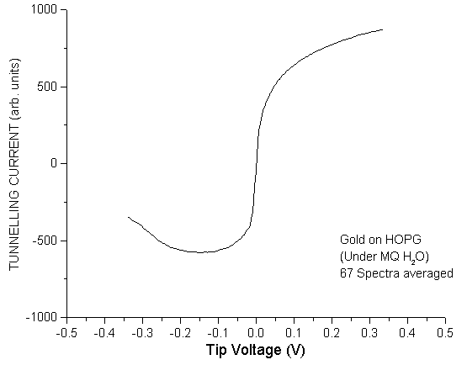
I/V spectrum of gold deposited on HOPG. Taken under ultra-pure water.
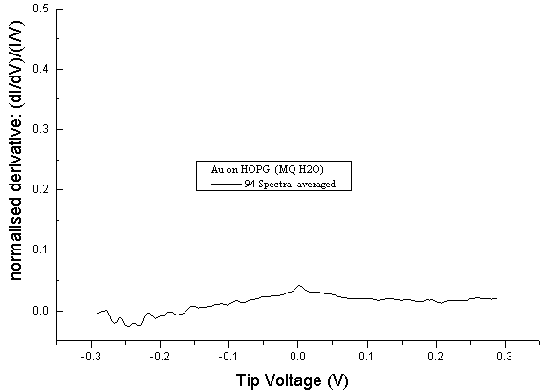
Figure 4.27
dI/dV spectrum of gold deposited on HOPG. Taken under ultra-pure water.

It is immediately obvious that the spectra are very different from the HOPG and silicon spectra. There is a very steep rise in the I/V graph near 0V, while the curves flatten out as the bias voltage increases in each direction. This is the reverse of the I/V graphs for the HOPG and the silicon. This means that it is very easy to differentiate between these elements just by observing the I/V spectra.

One other point worthy of note is the upward curve of the I/V graph for the gold covered by the ultra-pure water. A hint of this upward curve is noticeable in the I/V graph of the gold imaged in air, and was also observed in the I/V graphs of other metals. (see below) This translates into a small trough in the derivative graph. Just what is the cause of this effect was not discovered.

To check if there was any effect on the spectrum by the substrate, a layer of gold was sputtered directly onto one of the aluminium SEM stubs. This was then imaged and spectra were taken both in air and under ultra-pure water. The I/V spectra are displayed below as figure (4.28) for the spectra taken in air and figure (4.29) for the spectra taken under water. The I/V spectra for the gold deposited on HOPG are included for comparison.
Figure 4.28a Figure 4.28b
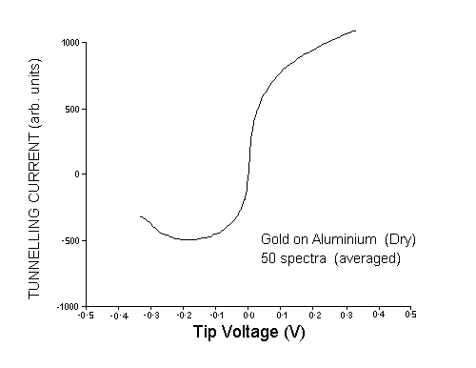
I/V spectrum of gold deposited on aluminium. I/V spectrum of gold deposited on HOPG.
Taken in air. Taken in air.

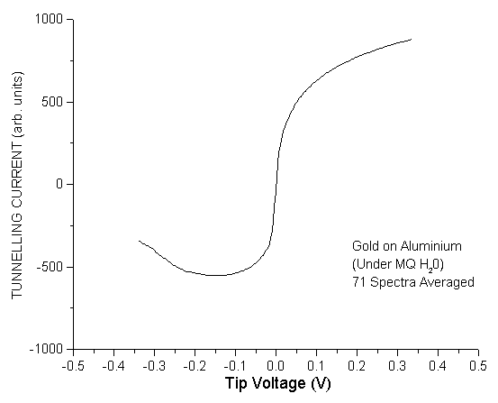
Figure 4.29a Figure 4.29b
I/V spectrum of gold deposited on aluminium. I/V spectrum of gold deposited on HOPG.
Taken under ultra-pure water. Taken under ultra-pure water.

The spectra resemble one another very closely, especially in figure (4.29). Here the spectra are almost identical. This indicates that a 50nm layer is thick enough to ensure that the spectra were derived solely from the deposited layer. This is what was expected from tunneling theory.

4.3.2.2 Platinum and Silver

Although the convolutions discussed in chapter 2 indicated that it would be unlikely that STS could distinguish between the noble metals gold, platinum, and silver, attempts were made to see if this was really the case.

Samples of platinum and silver were produced by sputtering the metals onto HOPG as discussed in section 3.2.2.1 of chapter 3. The samples were then imaged and spectra taken first in air and then with the samples covered with ultra-pure water. The spectra are shown on the next page. Figure (4.30) shows the averaged I/V spectrum for platinum in air, while figure (4.31) is the averaged I/V spectrum under ultra-pure water. Figures (4.32) and (4.33) are the corresponding spectra for silver.
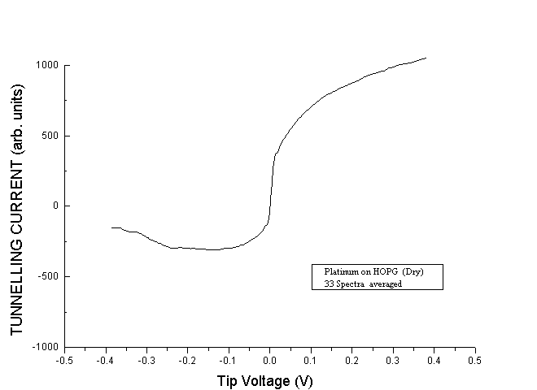

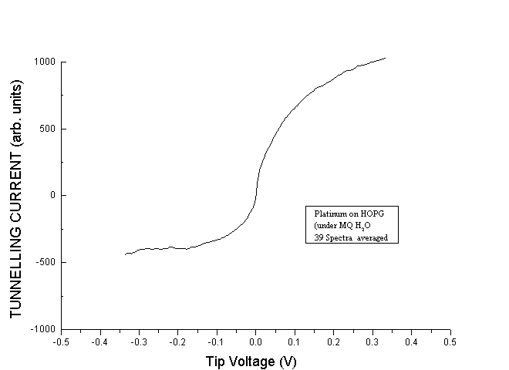

Figure 4.30 Figure 4.31
I/V spectrum of platinum deposited on HOPG. I/V spectrum of platinum deposited on HOPG.
Taken in air. Taken under ultra-pure water.
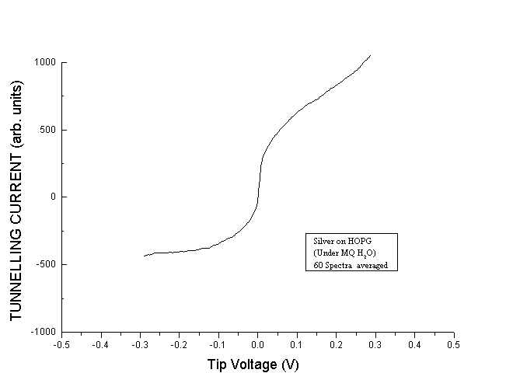
Figure 4.32 Figure 4.33
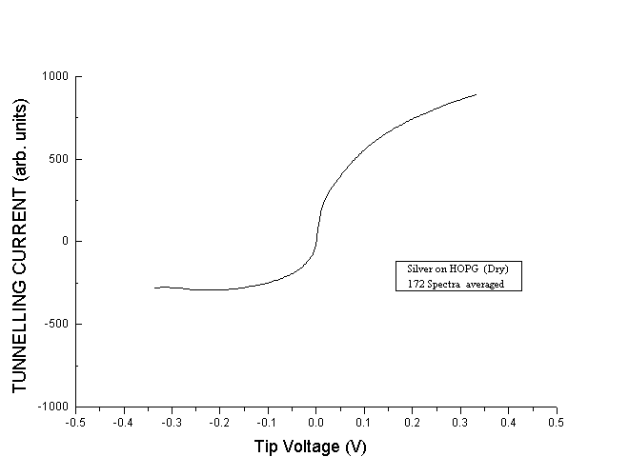
I/V spectrum of silver deposited on HOPG. I/V spectrum of silver deposited on HOPG.
Taken in air. Taken under ultra-pure water.

At first glance the spectra appear very similar, and also very similar to the gold spectra shown in figures (4.24) and (4.26). However there are some slight differences. The most obvious is at negative tip bias. The gold spectra turn upwards quite strongly in this region while the platinum spectra show only a small upturn and the silver spectra are essentially flat. Another slight difference is in the range of the spectra. This is most noticeable in the region of the steep increase near zero bias. Gold has the largest rise, then platinum, with silver having the smallest rise.

These slight differences would seem to indicate that it is possible to distinguish between the three metals using STS. However a note of caution is required here. The graphs are averages of a large number of spectra, the individual spectra can vary by a not inconsiderable amount. This variation would make it virtually impossible to distinguish the metals with just one or two spectra. It would also be interesting to observe the results of doing STS on a sample containing all 3 metals. Unfortunately, equipment problems and time constraints prevented this experiment being conducted.

      - Copper

Figure (4.34) below shows the I/V spectrum obtained from the copper sample in air. As can be seen, the curve is very different to that of both the semi-conductors and the noble metals. The almost constant slope implies a very flat normalized derivative, which is what was expected from the convolution investigation. (figure 2.11b) The dI/dV spectrum is shown in figure (4.35).
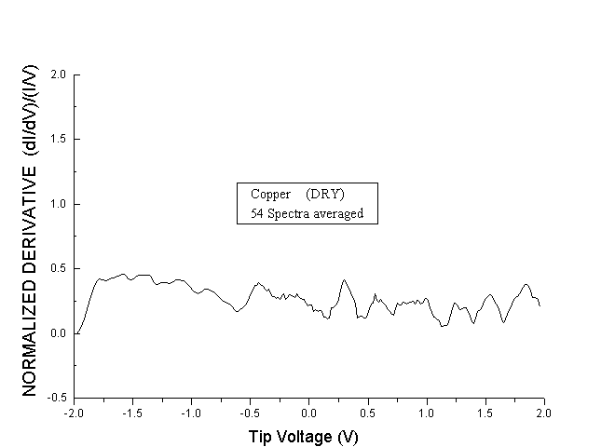
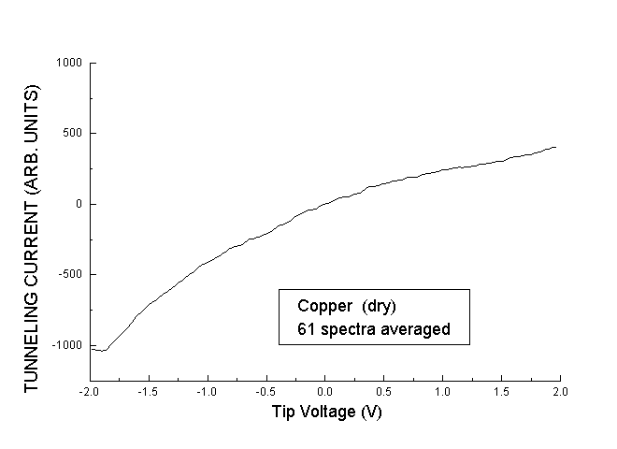
Figure 4.34 Figure 4.35
I/V spectrum of copper in air. dI/dV spectrum of copper. Taken in air.

    - Aurocyanide on HOPG

      - Potassium aurocyanide (KAu(CN)₂)

Having established that in situ STS could reliably distinguish between carbon, and a number of metals, and what the spectra looked like, attention was now directed towards one of the principal aims of this project, the investigation in situ STS of the adsorbate onto HOPG from a potassium aurocyanide solution.

The samples were prepared as discussed in section 3.5 of chapter 3. After the time allotted for adsorption had passed the sample was placed in the STM and a search was made to locate any deposits. Figure (4.36) shows a typical image of these deposits.
Figure 4.36
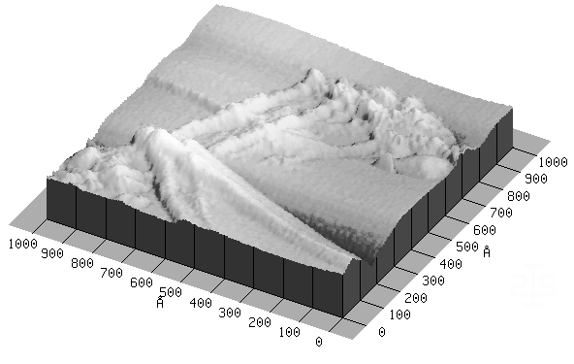
Image of deposit from potassium aurocyanide solution on HOPG.

Two interesting features are worth noting from this image. Firstly, the deposit is situated close to edges in the graphitic planes of the HOPG surface. This is in agreement with previous work undertaken at this laboratory. The second interesting feature is that the deposits are elongated and approximately parallel. This was a very common feature of larger deposits.

One other feature is illustrated by comparing figure (4.37a) with figure (4.37b) shown below. The difference between the two images is that figure (4.37b) was taken after several spectra had been taken on figure (4.37a). By comparing the two images, it can be seen that the taking of the spectra has altered the deposit by removing some of it. Great care had to be taken when obtaining spectra as it was very easy to disturb the deposits. This would indicate that the deposits are only very weakly attached to the HOPG surface, which suggests a physical rather than a chemical bond.

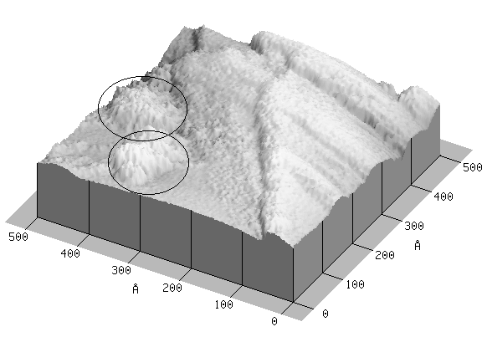
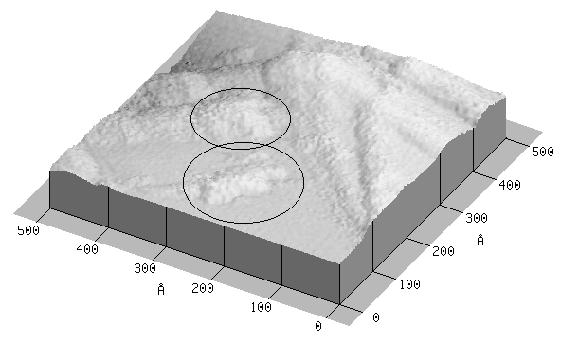
Figure 4.37a Figure 4.37b
Images of deposit from potassium aurocyanide solution on HOPG showing changes induced when taking spectra

Before undertaking any spectroscopy, a number of very small-scale images were made of small deposits to try for atomic resolution. In figure (4.38) shown below, the carbon atoms of the HOPG are clearly visible, while the adsorbed species is visible at the centre right.
Figure 4.38
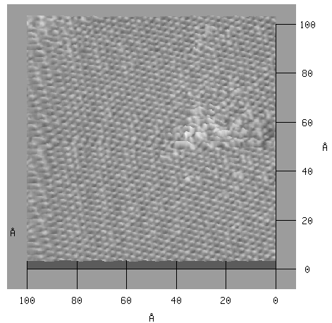
Atomically resolved image of deposit from potassium aurocyanide solution on HOPG.
A close look at this image shows that the atoms of the adsorbed species appear to be only slightly larger that the carbon atoms, and there is a slight tendency for the atoms to align in rows. The adsorbed species also appears to be higher than the carbon atoms. This is shown better in figure (4.39), which is the same image but displayed at a greater angle. In this image it can be seen that the adsorbed atoms are much higher than the carbon atoms. However, this does not mean that the adsorbed species is attached to the HOPG surface ‘end-on’, or that it builds up several layers rather than spreading out over the surface. As discussed in chapter 2, the STM topograph contains both topographical AND electronic information. Thus the higher features in the images may just be due to more tunnelling current from the adsorbed atoms.
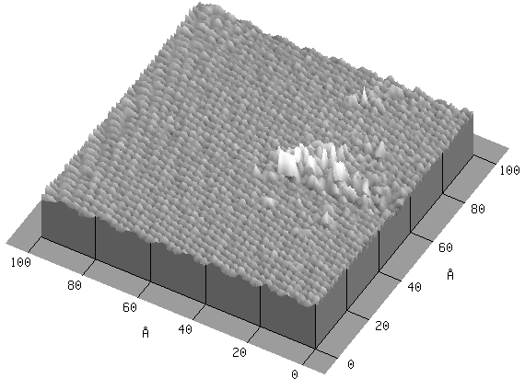
Figure 4.39
Atomically resolved image of deposit from potassium aurocyanide solution on HOPG

Figure (4.40) is a 3-dimensional view of another small deposit. This image shows the extreme apparent height of the adsorbed atoms very well. Since the height is considerable compared to the lateral size, it is most likely that the apparent height is due to electronic rather than topographic causes.

Figure 4.40
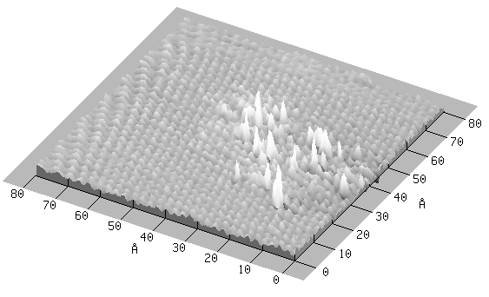
Atomically resolved image of deposit from potassium aurocyanide solution on HOPG.
showing the extreme height/diameter ratio of the adsorbed atoms.

The tendency for the adsorbed atoms to align in rows is well shown in figure (4.41). It is interesting to note that the rows in the deposit appear to match the alignment of the carbon atoms.
Figure 4.41
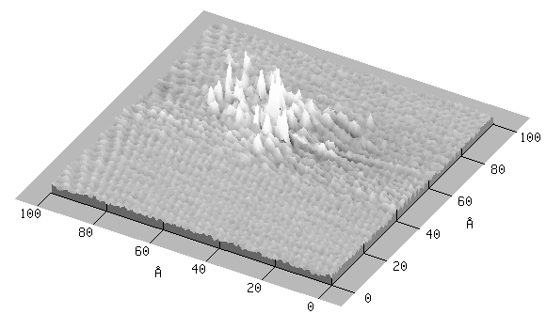
Atomically resolved image of deposit from potassium aurocyanide solution on HOPG
showing the tendency for adsorbed atoms to align in rows.

After a deposit was located and imaged spectra were taken. Mostly spectra were taken of the deposits however on some occasions spectra were taken of the surrounding carbon for comparison. When this was done the difference between the spectra were very obvious. Figure (4.42) shows one image of a deposit along with some carbon. Spectra obtained at 2 locations are displayed alongside the image. The differences are clear.
Figure 4.42
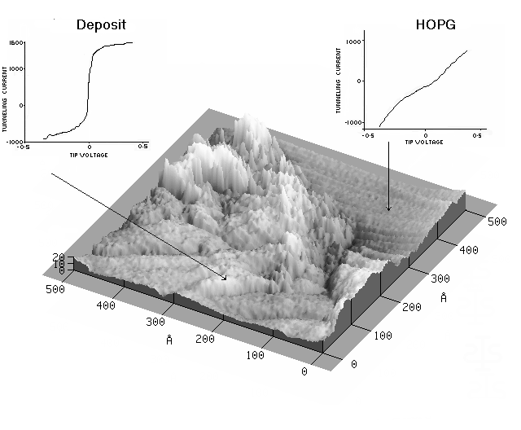
Spectra of deposit and of carbon showing the differences.

The averaged I/V spectrum obtained for the deposits is shown in figure (4.43).
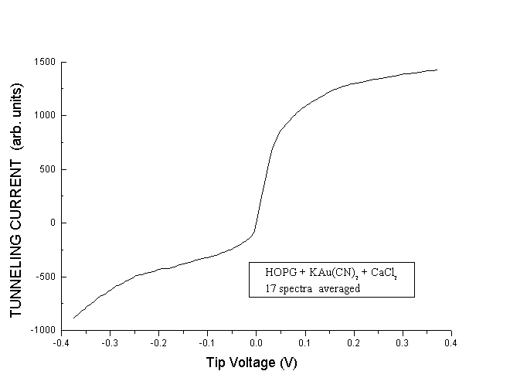
Figure 4.43 Averaged I/V spectrum of deposit.
Superficially, the spectrum resembles that for gold. However there are some differences, particularly on the negative tip bias portion of the graph. These differences will be discussed in more detail in the next chapter.

4.3.3.2 Aurocyanide (AuCN)
As part of the effort to identify the species adsorbed onto the HOPG discussed in the previous section, AuCN samples were prepared as discussed in section 3.4 of chapter 3. After preparation, the samples were placed in the STM and imaged to locate deposits. Once deposits were located, spectra were obtained.

Figure (4.44) shows the averaged I/V spectrum recorded on the AuCN deposits under ultra-pure water, while figure (4.45) is the averaged I/V spectrum under a weak HNO₃ solution.
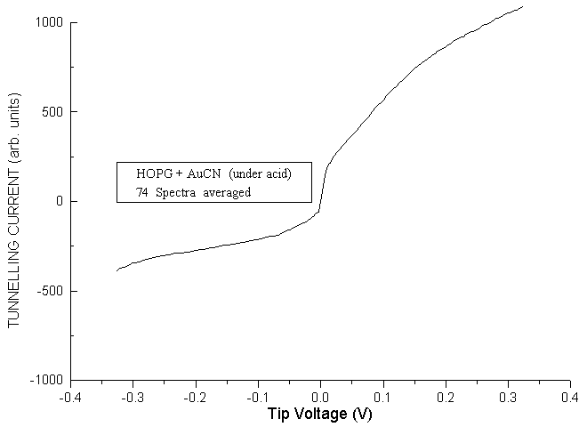
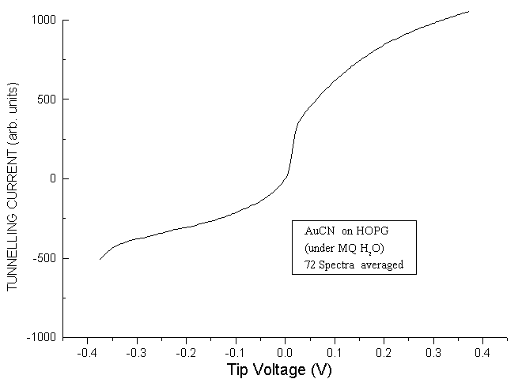
Figure 4.44 Figure 4.45
Spectrum of AuCN on HOPG Sprectum of AuCN on HOPG
under ultra-pure water under weak HNO₃

As can be seen, the two spectra are almost identical, so the solution has not had any effect on the spectra. Also the spectra closely resemble the spectrum in figure (4.43), which is the spectrum of the potassium aurocyanide solution deposits.

4.3.4 ACTIVATED CARBON

Since activated carbon is used in the mining industry to extract gold from gold bearing liquors, investigations were made of adsorption onto activated carbon for comparison to the results obtained on HOPG.

Initial experiments examined dry activated carbon samples as described in section 3.2.3 of chapter 3. Figure (4.46) is a typical image of the activated carbon. As expected, the surface was extremely rough, and this meant that the size of the area being scanned had to be kept small to avoid crashing the tip.

Figure 4.46
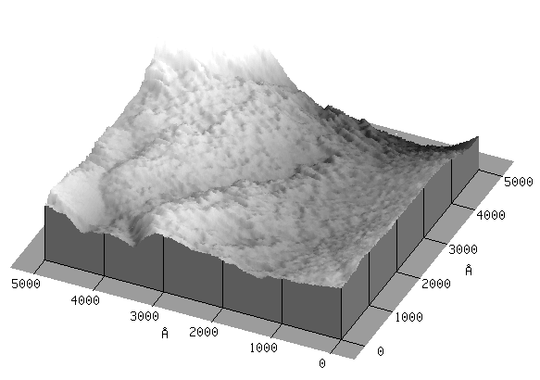
STM image of activated carbon in air.

Figure 4.47 shows a smaller scale image of the activated carbon. Even at this scale the surface is very rough.
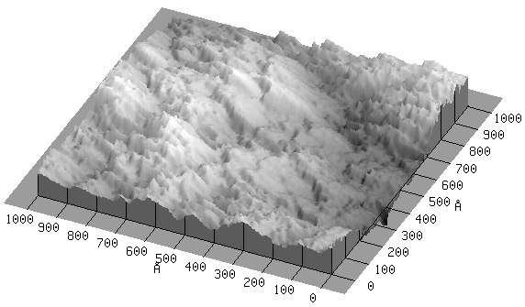Figure 4.47
STM image of activated carbon. Taken in air.

The spectrum obtained from the dry activated carbon is shown in figure (4.48). By comparing this graph to that of the HOPG shown in figure (4.17) it can be seen that although there are some similarities, the spectra do show some differences. This could be caused by a number of factors. However the most likely reason is functional groups attached to the carbon surface. It is also possible that the dilute nitric acid used in the attempt to remove any contaminants may have in fact reacted with these contaminants and functional groups giving further contamination, rather than removing them.

Figure 4.48
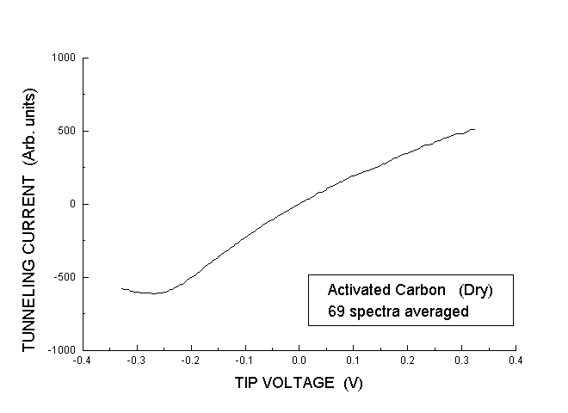
Averaged I/V spectrum of activated carbon. Taken in air.

Following the examination of the dry activated carbon, it was then covered with a solution of potassium aurocyanide and calcium chloride. After allowing time for deposition to occur, the sample was imaged with the STM to locate any deposits and spectra obtained. Figure (4.49) shows an image of one of these deposits, along with spectra obtained on the deposit and on nearby carbon. As with figure (4.42), the difference is clear, showing that it is comparatively straightforward to distinguish between the activated carbon and a gold-bearing deposit.
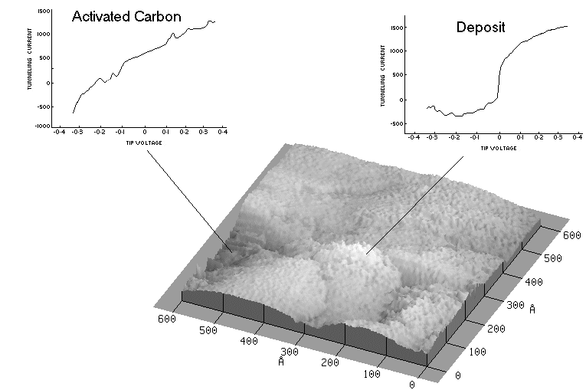
Figure 4.49
Spectra of deposit and activated carbon showing the differences.
Figure (4.50) shows the averaged I/V spectrum from the deposits. Comparing this graph to figure (4.43), it can be seen that the two graphs are very similar. This would indicate either, that the adsorbed species are very similar and possibly that a similar mechanism operates in the gold adsorption for both the clean HOPG and activated carbon, or the technique is unable to resolve any differences.
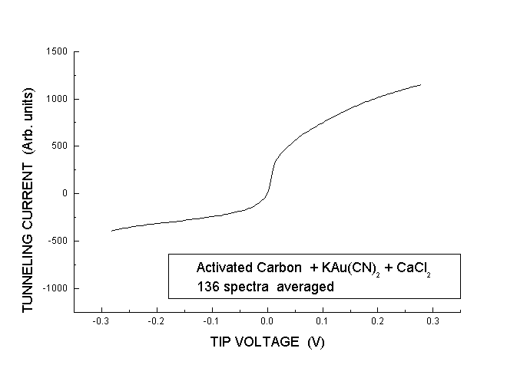
Figure 4.50
Averaged I/V spectrum of deposit.

