CHAPTER THREE

EXPERIMENTAL METHODS

  - EQUIPMENT

    - The Scanning Tunnelling Microscope

In principle, the operation of an STM is straight forward, however the computer control is essential in order to control the tip over the sample. The tip must be brought to within a few tens of angstroms of the sample surface and then scanned in a raster pattern accurately over a distance that may vary from a few angstroms to a few microns. The control of the tip is by means of the piezo tube, which is made of a polycrystalline ceramic. These materials have the property of changing size and shape when subjected to an electric field. This means that very fine control of the tip can be achieved by simply varying the D.C. field applied to the piezo. This is done under the control of the computer. Figure (3.1) shows the main components of an STM.

Figure 3.1
Schematic diagram of the main components of a scanning tunnelling microscope.
In approaching the sample, coarse approach is usually accomplished manually with a coarse adjuster while watching through an optical microscope. Fine approach is then achieved under computer control with the piezo-scanner. With a bias voltage applied, a tunnelling current will begin to flow between the sample and tip when the tip comes within about 50Ǻ of the sample. ⁽²⁾ The direction of the current flow will depend on the bias voltage applied as discussed in the previous chapter. Typically, the computer is set to detect a current of around 1nA. This current is then amplified and passed on the controlling electronics. As the tip scans across the sample, the distance between the sample surface and the tip changes, and the current, which is strongly dependent upon the distance, also changes. It is this change in current that provides the basic data from which an image is produced.

There are two methods of operating an STM, constant height and constant current. In constant current mode, a feedback loop monitors changes in current and moves the tip up and down to maintain a constant current flowing between the tip and the sample. The changes in height are recorded and used to produce an image. Constant current mode is the most common for operating the STM. Typically low scan rates (<10Hz) are used. This means that it is very suitable for scanning large areas, as the electronics will have time to react to changes in the height of the sample and so avoid crashing the tip into steps or mounds on the sample.

In constant height mode, the tip is maintained at a constant height above the sample surface and the changes in current are recorded, so producing an image. Generally in constant height mode the tip is scanned at high frequencies and so is suitable only for small scan sizes. Normally atomic resolution is easier to obtain in constant height mode although it is possible in constant current mode. For most scanning tunnelling spectroscopy constant current mode is used.

The electronics within the system must be of very low noise to avoid swamping the very tiny currents coming from the STM. Also the entire STM must be isolated from vibrations. The height changes and current variations produced by the STM head are very tiny, especially when trying for atomic resolution, and can easily be drowned out by vibration or electronic noise. This calls for the highest quality electrical components to be used in the construction of the STM, and for very effective shielding of the STM from the vibrations coming from the surrounding building.

The ambient STM used for this work was a Park Scientific Instruments, (PSI) tube-type scanner plus controlling electronics, (system control, feedback modules) with data acquisition and overall control via a Hewlett-Packard 382 controller. A PSI UHV-STM could also be operated by the system, however ongoing mechanical and electronic problems rendered the UHV-STM inoperative throughout the time of the project. The ambient STM head was mounted in an acoustic box sitting on a vibration isolating air table, both of which were designed and largely constructed at Murdoch.⁽⁵⁾ Such protection was necessary due to the unfavourable location of the laboratory on the top floor of the building, near a stairwell and doors that had a tendency to slam. Also the STM was in close proximity to a UHV system, the pumps for which were a major source of vibration. The entire setup is shown below in figure (3.4).

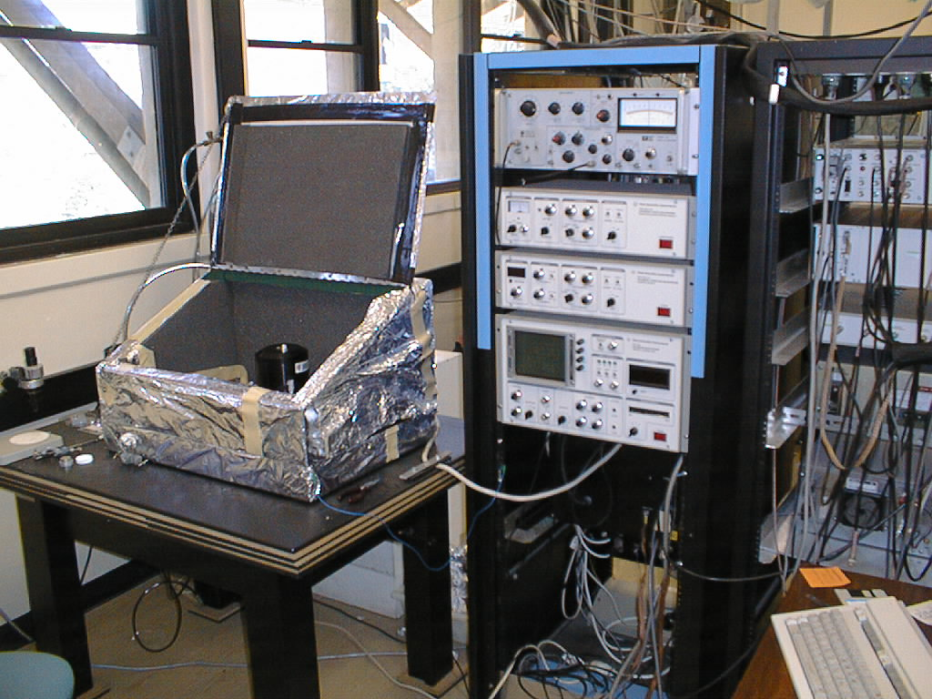
Figure 3.4
The STM setup at Murdoch.

On the left is the STM, sitting on the air-table inside its acoustic box. On the right are the control electronics. Just visible at the lower right is the keyboard for the control computer. This computer was also used to display the images and to store the data.

The effect of the shielding and vibration isolation can be seen in the images below. Figure (3.5) shows graphite imaged without any vibration protection while figure (3.6) has the air table raised and the acoustic box closed. The effects of the vibration are clearly visible.

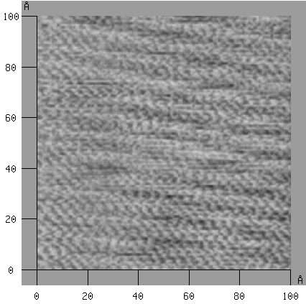
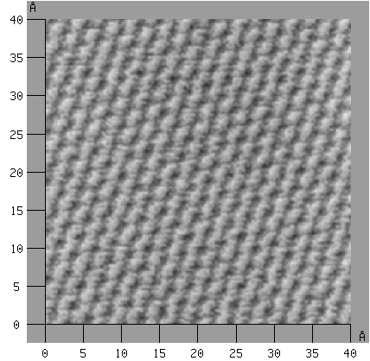
Figure 3.5 Figure 3.6
STM image of HOPG made with the air table STM image of HOPG made with the air
lowered and with the acoustic box open. table raised and the acoustic box closed

The ambient STM consists of a base and an interchangeable STM head. 2 STM heads were available, a 2.5μ and a 10μ. For the majority of the work in this project the 2.5μ scanner was used. The STM is shown in figure (3.7)
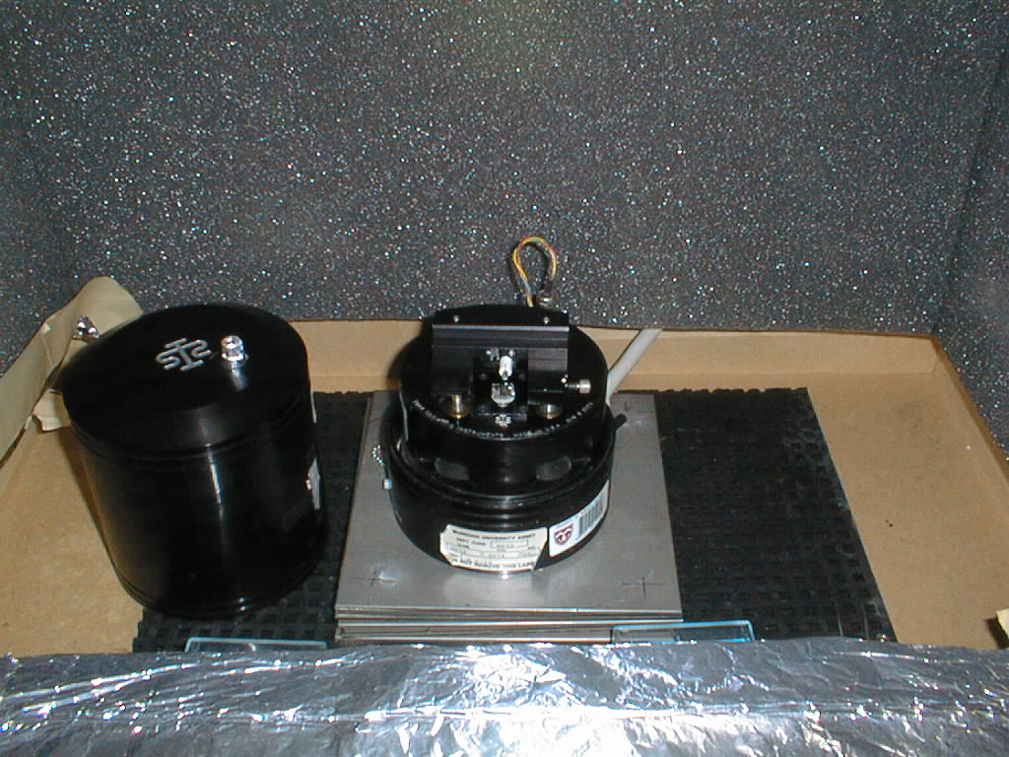
Figure 3.7 The Park Scientific Instruments STM at Murdoch.
The PSI STM is designed to hold scanning electron microscope pin stubs. Samples were attached to the aluminium stubs by means of electrically conducting, adhesive carbon tabs. The stub is then placed in the scanner and the tip set in place. Coarse approach was accomplished manually by means of two front mounted, height adjustment screws, which would raise or lower the tip. While the screws were adjusted, the approach of the tip was observed by eye with the help of an optical microscope, as shown in figure (3.8).
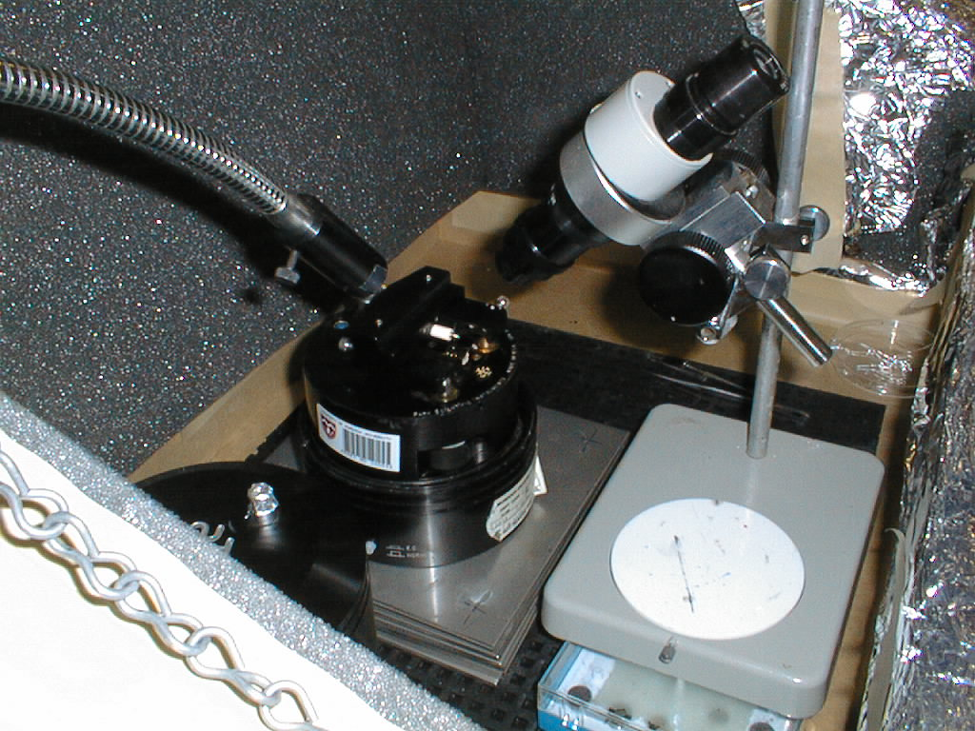
Figure 3.8
The setup used for the coarse approach.

Care had to be taken to avoid crashing the tip onto the sample as this would ruin the tip and require its replacement. Generally this was not a problem as the closeness of the tip to the sample could be observed by watching both the actual tip and its reflection, and stopping the coarse approach when the two were sufficiently close to each other. This method worked very well and even on a rough surface such as activated carbon, sufficient reflection occurred, even under liquid.

Once the coarse approach was completed, the cover would be placed over the scanner and the box closed. Fine approach was conducted under computer control. The computer would lower the tip by means of a third screw located at the back of the scanner, until sufficient tunnelling current was detected. The values of the tunnelling current and bias voltage were set on the control panel prior to fine approach. In general, the tunnelling current was set at 1nA, while the bias voltage was set at anywhere between ± 0.01V and 6V, depending on the particular experiment.

With the PSI system a number of operating modes were available. The first 3 modes gave images of either 128 x 128, 256 x 256, or 512 x 512 pixels per image. The first mode also allowed I/V spectra to be obtained at 8 individual locations in the image. Mode 4 was for voltage dependent imaging and would produce 2, 128 x 128 pixel images. Mode 5 produced simultaneous topographic and spectroscopic images. The spectroscopic image could be either the local conductance (dI/dV) or dI/dZ. Some of the work for this project was conducted with this mode. Mode 6 was for CITS.

3.2.2 Tips and Tip Preparation

One of the most important components of the STM setup is the tip. Even the most low-noise electronics, the most perfect vibration isolation system, and the best prepared samples, will yield poor results if the tip preparation results in poor quality tips. A variety of models have been proposed for how the tip actually works, however the most satisfactory model is that of a single atom or small cluster of atoms at the end of the tip being the active area. ⁽⁶⁾ The tip must have a thick body terminating in a short, single tip. Problems can occur if the tip has multiple ends or minitips. For example, if there are 2 minitips that are widely spaced, then the tip through which tunnelling will occur can change during imaging, depending on which minitip is closest to the sample surface. This is shown in figure (3.9) This can lead to double images or distorted images.

Figure 3.9
Schematic diagram of what can happen when multiple tips exist.

If atomic resolution is desired, then a very sharp tip is required, as the tip cannot accurately image details on the surface smaller than the tip. If the surface of the tip is rougher than the surface, then an image of the tip may be produced rather than the surface. (Figure 3.10) Also the tip must be very stable on an atomic scale, as any movement of atoms at the tip will effect the measurements.

Figure 3.10
Schematic diagram of problems caused by a blunt tip. In figure 3.10a the tip cannot resolve small detail. In figure 3.10b the tip is imaged rather than the sample.

Finally, if the imaging is to be conducted under a conducting medium such as water, then the tip must be insulated for most of its length with an inert material to minimize the Faradic current.

Unfortunately there is no way of knowing how a tip will perform until it is actually used. Also, a foolproof method for producing tips has yet to be developed. Sometimes the most careful and precise procedures will produce dud tips, while at other times a haphazard method will produce a good tip. For example Colton et al achieved atomic resolution on graphite using a piece of broken lead (polycrystalline graphite) pencil as a tip. The most important aspect is to develop a procedure that will produce a significant proportion of good tips.

In general, either tungsten or platinum metal is used in making tips although other materials such as gold and rhenium have also been tried and found effective. Despite the material chosen however, the actual identity of the atoms forming the tunnelling tip is very unlikely to be known. There may well be impurities in the material, and particularly for in situ studies, where there is a strong possibility of oxides or contaminants. There is also the possibility of the transference of atoms from the sample to the tip. This is particularly a concern in spectroscopy where the use of a large voltage range can result in damage to the surface.

In this project, the material used to produce the tips was either, 0.5mm diameter, polycrystalline tungsten wire, or 80%-20% polycrystalline, platinum-iridium wire 0.25mm in diameter. For the spectroscopy, it was found that the platinum-iridium wire produced the most consistent results.

Generally the production of the tips was by electrochemical etching in a process developed at Murdoch University by adapting a method of Libioulle et al.
Some tungsten tips were made by mechanical means, by cutting the wire at an angle of 45°. However it was found that tips made in this manner were less reliable and tended to have a higher proportion of multiple tips. For this reason tips produced by electrochemical etching were preferred.

For the electrochemical etching of tungsten tips, a 1.5M NaOH solution with a small amount of acetone added was used as the etching solution. The addition of a small amount of acetone reduced the formation of oxides and produced a sharper tip. With the wire in the solution, an ac voltage of about 23V is applied for about 10 seconds, after which it is reduced to about 16V. The wire is then etched until no wire is in contact with the solution, forming the tip. The same process was used for the Pt-Ir tips, except a 1.5M NaCN/NaOH solution was used instead of just NaOH

After etching, the tip was washed in hot, ultra-pure water (18MΩ millipore) to remove any solution, and then rinsed with isopropanol and dried. Tips were made in batches of 4 or 5, and stored under glass to reduce the rate of contamination.

Tips produced in this fashion were found to be of very good quality and readily reproducible with around 80% of the Pt/Ir tips and about 60% of the W tips made producing good results.
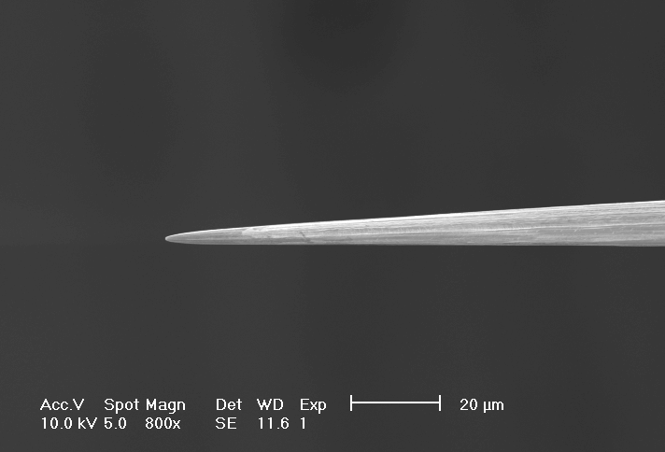
Figure 3.12
SEM image of a Pt/Ir tip

For the tips to be used in the in situ experiments, the tips were coated with apiezon wax in a procedure also developed at Murdoch, and shown schematically in figure (3.13). In this process the apiezon wax is heated to a temperature of between 240°C and 260°C and the tip is dipped into the wax 2 or 3 times for about 10 seconds each time. The quality of the wax coating is vital. If too much of the tip is covered then the tip will not work. However if too little of the tip is covered, then the Faradic current will be too high and will swamp the tunnelling current. The temperature of the wax is the critical factor, as this determines the surface tension of the wax and therefore how much of the tip is left uncoated. Previous work in this lab found that a temperature between 240° C and 260° C produced the best results.

Figure 3.13
Schematic diagram of the setup for coating STM tips with apiezon wax.

An example of a coated tip is shown in figure (3.14). In this image the wax coating can be seen to cover all but the very end of the tip.

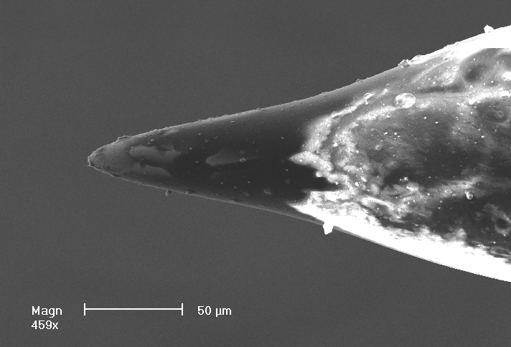
Figure 3.14
SEM image of an STM tip coated with apiezon wax.
  - SAMPLE PREPARATION

    - SEMI-CONDUCTORS

3.3.1.1 Graphite

For all of the graphite studies, highly orientated pyrolytic graphite (HOPG) was purchased from Advanced Ceramics (formerly a division of Union Carbide) in 1cm squares. HOPG is an ideal substrate for STM investigations. It has a well-characterized surface which is very easy to cleave, making a clean, fresh surface easy to obtain. HOPG also has large, (on an atomic scale) flat regions that are comparatively easy to resolve atomically. Several grades of HOPG were available, with the principal difference being the ease of cleaving and the amount of “steps” in the cleaved surface. For virtually all of the experiments the highest grade, ZYA, was used.

Cleaving was accomplished by the use of adhesive tape, which was lightly pressed onto the HOPG surface and then pulled off. As the tape pulled away from the HOPG, it would pull away a thin layer of the HOPG, thus exposing a fresh surface. Cleaving was repeated several times to ensure that a completely fresh surface, uncontaminated by any previous experiments, was available.

3.3.1.2 Silicon

For the experiments using silicon, p-type amorphous silicon was obtained from the amorphous silicon laboratory at Murdoch. Since the experiments were not conducted in vacuum, it was not possible to have a pure silicon surface due to oxidation. In view of this, no special preparation of the surface was undertaken. This means that the surface actually studied was silicon dioxide. The chips of silicon were attached to the SEM stubs by means of conducting silver epoxy. A fresh piece of silicon was used each time a new set of experiments was conducted.

      - Galena (lead sulphide)

Several samples of lead sulphide had been obtained for the laboratory by a previous researcher. These samples were freshly cleaved prior to each experiment by a sharp blow to the back of a sharp knife, which removed the surface layers.

    - METALS

3.3.2.1 Noble Metals

Several experiments were made using various noble metals deposited on different substrates. To prepare these samples, freshly cleaved or cleaned substrates were placed in a Balzers Union 020 Sputter Coating device, which was then evacuated to a pressure of 4 x 10⁻⁴ Torr. Highly pure metal targets were bombarded with argon, sputtering metal atoms onto the substrate. When sputtering first commenced, the substrate was covered to ensure any contaminant on the surface of the target did not reach the substrate. A layer of approximately 50nm was deposited, either as a complete coverage of the substrate, or for some experiments, as a partial coverage. Several methods for obtaining a partial coverage of the substrate were tried. The method that was found to be most reliable was to cover half of the substrate with adhesive tape, which was removed after deposition.

Once the metal had been deposited onto the substrate, it was generally about one hour before the experiments could begin. This was an unavoidable circumstance caused by the location of the sputtering equipment. Therefore some airborne contaminants such as oxygen could have adsorbed onto the surface.

      - Copper

Several attempts were made to deposit a thin layer of copper onto HOPG by sputtering as for the noble metals. However it was found that the copper layer oxidized much too rapidly to allow analysis with the STM. As a result, pure copper sheet was obtained and several samples were cut from this sheet and mounted onto the STM mounting stubs. Before mounting, each sample was washed for a period of time in dilute nitric acid to remove any contaminants and then rinsed in ultra-pure water. A fresh sample was used for each experiment.

3.3.3 Activated carbon

Activated carbon produced from peach pips was used in this project. To ensure a surface as free as possible from contamination, the samples were soaked for several days in dilute nitric acid, followed by several days soaking in ultra-pure water.

Conducting silver epoxy was used to attach the activated carbon chips to the SEM stubs with the outer edges being made a little higher to hold any solutions and to prevent any contact between the solution and the aluminum stub.

3.3.4 Gold Cyanide (AuCN)
In order to obtain deposits of AuCN on the HOPG, several drops of KAu(CN)₂ solution were placed onto the HOPG sample and several drops of dilute HNO₃ were added. This led to the formation of AuCN via the reaction;

KAu(CN)₂ + HNO₃ → KNO₃ + HCN + AuCN

In this reaction, the KNO₃ and the HCN remained in solution. There was insufficient HCN produced for any gas to be liberated. This was for safety reasons. The AuCN produced was deposited onto the HOPG. Dilute KNO₃ was used in the course of conducting the experiments, and it was found that if the acid was too concentrated, the solution would break down the tip coating, rendering the tip useless.

    - Potassium Gold Cyanide (KAu(CN)₂)

For the aurocyanide adsorption experiments, potassium aurocyanide salt (KAu(CN)₂) was purchased and used to produce a 1000ppm Au solution. The pH of the solution was adjusted to around 10 with KOH to prevent the formation of the toxic gas, HCN.

The calcium solution was prepared from calcium chloride, diluted such that a 1000ppm Ca++ solution resulted.

A Pasteur pipette was used to place several drops of the solution onto the sample, which was then placed inside an upturned glass jar on the lid. To prevent evaporation, a small beaker containing more of the solution was also placed inside the jar, which was then sealed. The system was then left undisturbed for between 32 and 48 hours to allow adsorption to occur.

3.4 SOLUTIONS

In the preparation of all solutions, only analytical grade reagents were used, along with 18MΩ ultra-pure water.

A number of experiments were conducted under neutral liquid conditions. For all except one, this liquid was ultra-pure water. The exception was the silicon experiments. For these, the liquid used was diffusion pump oil.

When the experiments were being conducted in situ with the STM, a small beaker of ultra-pure water was placed in the STM with the sample to increase the humidity and minimize evaporation.

For most of the aurocyanide experiments, 3 drops of aurocyanide solution were placed on the HOPG along with 3 drops of the CaCl₂. This was done since, as discussed in section 1.4 of chapter 1, previous work in this laboratory has found that the addition of Ca⁺⁺ ions significantly increased the adsorption of the aurocyanide.

3.5 IMAGING METHODS

As mentioned earlier in this chapter, a number of different methods of imaging and of obtaining spectroscopic data, were available with the Park STM. In general, the practice adopted was to first make an overall sweep of the sample to the maximum size that could be covered by the STM. (2.5μ) This was to locate any interesting features. If any were located, then a more detailed study was then undertaken. If none were located, then the tip was relocated to a different portion of the sample. These large-scale images were all obtained using the Mode 1 setting and constant current mode. For small-scale imaging, such as when trying to obtain atomic resolution, Mode 1 and constant height mode was used.

3.6 SPECTROSCOPY METHODS

Three techniques were used to obtain spectroscopic data. The first two methods used were conductance imaging methods, obtained using Mode 5. As alluded to earlier, both of these methods produced two simultaneous images. The first image was a normal topographic image. The second image was either a map of current variation with voltage (dI/dV), of current variation with height (dI/dZ), depending on which method was chosen. Although both methods were used, it was found that the (dI/dV) images yielded the most information and so this was the method predominantly used.

The third technique used was I/V spectra obtained using Mode 1. Here an image was obtained and then the tip was placed over a location of interest. Then the bias voltage was rapidly ramped between the negative and positive values of a preset voltage as discussed in chapter 2. Up to 8 spectra could be obtained for each image.

