CHAPTER ONE

INTRODUCTION

Gold exists on the Earth as a free metal, chemically combined with tellurium and as inclusions in quartz and various pyrites. It is a group 1B element, and is considered a noble metal, as it shows no reactivity with common reagents. Gold does have 4 oxidation states, Au(I), Au(II), Au(III) and Au(V). The first 3 states can form stable compounds. Generally speaking, the oxidation of gold in solution requires both oxidizing and complexation agents to be present.
Very often, metallic gold is found as alluvial or placer deposits in river systems where the metal has been eroded from its original location. (the ‘mother lode’ of gold rush fame) This eroded material is carried downstream where, because of its high density (19.3 g/cm⁻³), it will quickly settle out when the stream flow is reduced. Much of this metallic gold is associated with silver, with individual gold grains containing as much as 30% silver surrounded by a thin layer of pure gold. This is illustrated in Figure 1.1, which is an SEM image of one such gold grain. The darker regions of the grain are almost pure gold (>95%), while the lighter regions contain 20% - 30% silver. Just why these outer regions are silver enriched is the subject of some debate.
Figure (1.1)
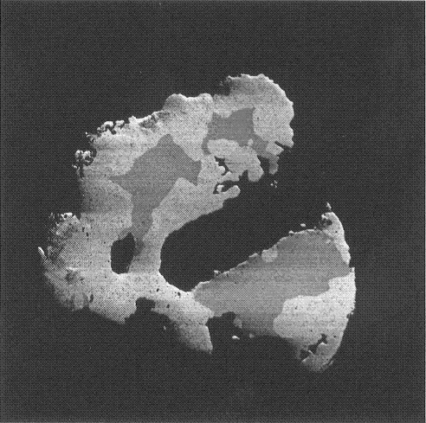
Kalgoorlie gold grains sample. Grain 10 Row 2. BSE image 30kV 600X
One of the earliest methods of extracting gold from the ground was by gravitationally separating the gold from the much less dense rock using pans or sluices. Many of the gold rushes of the 1800’s used this method for mining placer deposits. A more efficient method, known since Roman times, is the use of mercury to dissolve the gold to form a mercury/gold amalgam, from which the gold may be recovered by distillation of the amalgam.
A very common method used in the 1800’s was to leach the gold from an ore slurry using chlorine. During the late 19th century the use of cyanide to leach the gold from the ore was introduced. The process is not without its problems, some of which are the toxicity of the cyanide, the necessity of maintaining an alkaline solution, and sulphide-containing ores that must be pre-treated. Low leaching rates can also be a problem, with as much as 72 hours being required for the leaching step. Despite these hindrances, the use of cyanide gradually replaced chlorine as the preferred method of extracting gold from ore.
In the cyanidation process, the ore is finely crushed and then placed in a caustic solution containing the cyanide, forming a pulp. The use of a caustic solution is to prevent the formation of the highly poisonous gas HCN. The cyanide reacts with the gold in the pulp to form the aurocyanide ion (Au(CN)₂)⁻ as described by the following equations;
2Au + 4CN⁻ + O₂ + 2H₂O ↔ 2(Au(CN)₂)⁻ + H₂O₂ + 2OH⁻
2Au + 4CN⁻ + H₂O₂ ↔ 2(Au(CN)₂)⁻ + 2OH⁻
These reactions result in a dilute solution of aurocyanide. This is known as the leaching step.
One early method for recovering the gold from this solution was developed by Merill in the late 1890’s and then substantially improved by Crowe in 1918. In the process originally developed by Merill, the gold bearing solution was clarified and then zinc dust was added. The zinc precipitated the gold according to the following reaction;
Au(CN)₂⁻ + Zn + 2CN⁻ + H₂O → Au + Zn(CN)₄²⁻ + OH⁻ + 0.5H₂
It was found that the reaction is very poor if oxygen is present in the solution, however Crowe used a vacuum deaerator to remove the oxygen prior to the addition of the zinc dust, which resulted in a substantial improvement in the reaction. It was also discovered that the addition of lead assisted the precipitation of the gold. ⁽⁸⁾ For some 60 years this very efficient process remained the standard for the extraction of gold.
Around the same time that Merill was developing the zinc precipitation process, a process of using carbon in the form of charcoal to remove the aurocyanide from the solution was being introduced, known as the carbon-in-pulp (CIP) process. In the early days the gold was recovered from the charcoal by burning the charcoal and then smelting the gold from the remaining ash. This was a very expensive practice and as a result the CIP process was seldom used. The situation changed around 1950 however, when Zadra developed a procedure for recovering the gold in a way that allowed the carbon to be reused. Another major improvement was the introduction of activated carbon instead of charcoal. These changes have made the CIP method not only very efficient but also very economical.
In the CIP process the gold ore is treated with an alkaline cyanide solution in a leaching step as described earlier. The gold bearing pulp from this step is then passed into another vat containing the activated carbon. Here the gold cyanide species are adsorbed onto the surface of the carbon. A variation of this process is to add the activated carbon directly into the leaching tanks. This is known as the Carbon in Leach process. The gold cyanide species are removed by soaking the carbon in hot (95° C) water in the presence of hydroxide and a small amount of NaCN. The gold is then extracted from this solution by electrowinning. The carbon can be reactivated by heating to around 600°C in the presence of steam.
The key step in this process is the adsorption of the aurocyanide by the activated carbon. Activated carbon has the very important property of being able to selectively adsorb even small amounts of gold cyanide complexes in the presence of high concentrations of other metal cyanide complexes. This makes the CIP process very important for mining low-grade ores. Using the CIP process, or one of its close analogues, the Carbon-in-Leach (CIL) or the Carbon-in-Column (CIC), it is possible to economically mine ores as low as 2 grams of gold per tonne of gangue.

1.2 Activated Carbon
Activated carbon can be produced from almost any carbonaceous material. Among the more common source materials are coconut shells and peat. Activated carbon is used in a wide variety of processes and different source materials tend to be used for different applications as both the source and the manufacturing process have an effect on the physical and chemical properties of the activated carbon. For the CIP process, activated carbon produced from coconut shells is generally used.
Activation of the carbonaceous material is usually a two-step process. Firstly the material is heated to around 500°C in the presence of dehydrating agents. This process carbonizes the material and produces numerous micropores in the material resulting in a greatly increased surface area. In the second step, the material is heated up to as high as 1000°C in the presence of steam and/or oxygen. This further enhances the formation of micropores and results in the activated carbon having a surface area of up to 2000 m² /g. The exact nature of the pores produced and the surface area depend partly on the source material and partly on the activation procedure. The activated carbon used in the gold mining industry generally has a high proportion of micropores and a large surface area. It has been found that a large surface area can enhance the adsorption of the gold.

High magnification SEM image of activated carbon showing some pore structure
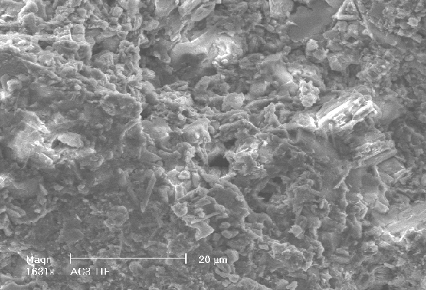

The physical structure of activated carbon is considered to be similar to graphite but with considerable disorder. In the activated carbon, there are small regions of approximately parallel planes of graphitic carbon connected by a disordered lattice of carbon hexagons. The sizes of these graphitic regions are dependent upon the temperature at which the activation is conducted, but are generally around 12Å high and 20Å wide. Work undertaken by Ibrado and Fuerstenau and by Miller and Sibrell, have indicated that it is these graphitic structures in the activated carbon which play the dominant role in the adsorption of gold cyanide.
1.3 Gold Adsorption
Work by Ibrado and Fuersteneau demonstrated that the graphitic nature of the substrate is the crucial factor for gold loading. They also confirmed that the aurocyanide adsorbed intact and parallel to the surface. However Klauber’s model has been challenged by Sibrell and Miller who also used XPS along with radiochemical methods. Their results showed much greater adsorption at the edges of the graphite plates rather than on the basal planes. Klauber’s model also did not take into account the results of South African researchers, who proposed that a counter cation must be present to anchor the negatively charged aurocyanide ion complex to the negatively charged carbon surface.
At Murdoch, it was believed that the study of gold cyanide adsorption could be fruitfully extended by the use of an ambient Scanning Tunnelling Microscope (STM) to examine the adsorption of aurocyanide onto graphite. Two particular advantages in using this approach were the potential for atomic resolution of the surface and the ability to undertake experiments in situ. The study was initiated by G. Kirton as part of his Honours research and then extended by Dr G. Poinen in his doctoral thesis.
Initial work by G. Kirton established that the STM could be used successfully to image gold deposits on highly orientated pyrolytic graphite (HOPG) under solution. Dr Poinen, in his extensive study of aurocyanide adsorption, showed that very little gold adsorbed onto HOPG unless a metal ion (calcium) was also present in the solution. When calcium was present Dr Poinen’s results showed that material was deposited preferentially near step edges on the HOPG surface. As a result of his work, Dr Poinen proposed that the calcium ions were intercalating between the graphite sheets at step edges. This would cause a slight positive charge at the surface that could attract the negatively charged aurocyanide ion.
The aim of this study was to extend the work of previous A.J. Parker PhD. students, Gavin Kirton and Gerard Poinen, into the adsorption of gold onto carbon. These earlier studies provided some valuable insights into the aurocyanide adsorption mechanism. However they suffered due to an inability to identify the chemical species of which deposits were composed. The reason for this is that while STM images provide very good topography of a surface down to atomic resolution, the images themselves do not provide any direct information as to the composition of surface deposits.

Scanning Tunnelling Spectroscopy (STS), which uses the electronic information obtainable with the STM, has the potential to supply this data, possibly on an atom-by-atom basis. In a number of studies under ultra-high vacuum conditions, STS has been successfully used to identify surface atoms. So the principle aim of this study was twofold. Firstly, to investigate the feasibility of using scanning tunnelling spectroscopy (STS) under solution to identify different materials, then, if the technique proved reliable, to use STS to continue the study of the adsorption of aurocyanide onto carbon.

