Unit 18 Reading A

Biological effect

The particles or electromagnetic waves that are emitted from radioactive nuclei can have damaging effects on living cells. When they pass through living tissue they can remove electrons from atoms and molecules, leaving ionized particles. This can interfere with cell reproduction and lead to cell death, causing cancer and genetic defects. There are also constructive uses of radiation: it can be used to cure cancer and for medical diagnostic purposes.

The biological effects are directly proportional to the number of particles ionized. The number of particles ionized depends on the type of radiation and the amount of energy deposited in the living tissue. Radiation dosage is reported in terms of the amount of energy deposited in the mass of tissue that was exposed to radiation per unit mass of the tissue. The rad (radiation absorbed dose) is defined as

The biological effect of the same dose in rads is different for different types of radiation. A unit that takes the type of radiation into account is the roentgen equivalent man (rem). A rem is the dosage in rads multiplied by a factor that depends on the type of radiation, the relative biological effectiveness factor (RBE):

The RBE for different kinds of radiation is given in the table below. The same dose in rem produces the same effect on tissue.

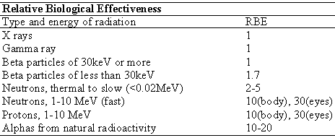
(from Peter Paul Urone, Physics with Health Science Applications, John Wiley and Sons, NY, 1986)

