UNIT 11 READING A

Consider the series combinations of nichrome wire shown in the figure below.

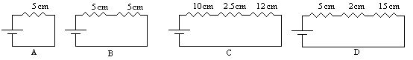
Each of these combinations is called a series network. Each of the series networks could be replaced by a single piece of nichrome wire that has the same resistance as the series network as shown in the figure below.

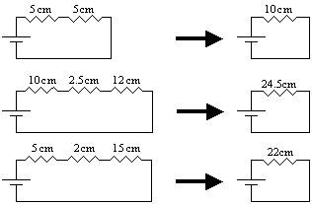

The total resistance of a series network is given mathematically as the sum of the resistances in the network:

$R_{\text{TOT}}=R_{1}+R_{2}+R_{3}+⋅$

The total resistance is the (single) resistance with which you could replace the network. Is this consistent with the work you have done in lab so far? Explain.

Consider the parallel combinations of nichrome wire shown in the figure below.

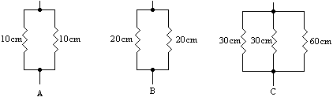

Each of these combinations is called a parallel network. Each of the parallel networks could be replaced by a single piece of nichrome wire that has the same resistance as the parallel network as shown in the figure below.

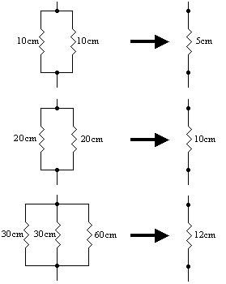

The total resistance of a parallel network is given mathematically as follows:

$\frac{1}{R_{\text{TOT}}}=\frac{1}{R_{1}}+\frac{1}{R_{2}}+\frac{1}{R_{3}}+⋅$

The total resistance is the (single) resistance with which you could replace the network. Is this consistent with the work you have done in lab so far? Explain.

If you have both series and parallel combinations, you must break it into parts as in the example below.

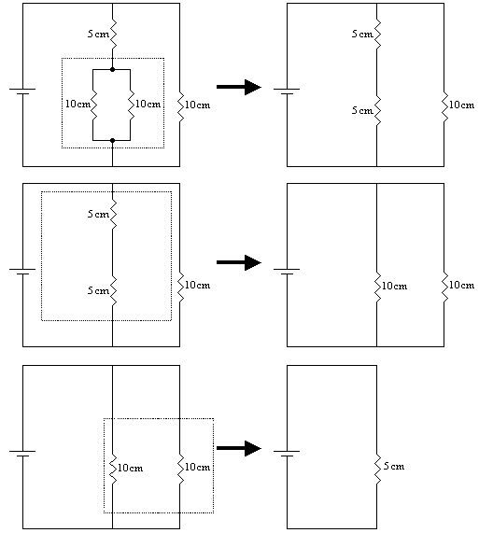

The network could be replaced by a single 5cm resistor.

