UNIT 19 PRETEST

1) Consider a bulb, lens and screen arranged as in the diagram below. An image of the filament of the bulb is on the screen. If half of the lens were covered with a piece of cardboard, what would happen to the image on the screen? Explain your reasoning.

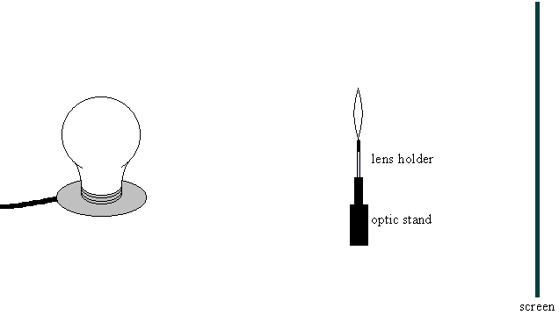

2) Consider a nail placed near a mirror as in the picture below. Where is the image of the nail? Is the image upright or inverted? Explain your reasoning.



3) Consider a nail placed 10cm from a 20cm focal length lens as in the picture below. Where is the image of the nail? Is the image upright or inverted? Is the image real or virtual? Explain your reasoning.
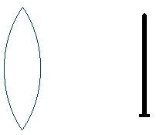

4) How does a fiber optic cable work? Explain your reasoning.

5) How is the image of an object formed on the film of a camera? Explain your reasoning.

