UNIT 16 PRETEST

1) A magnet is held near a loop of wire. Would there be a current through the wire? If so, which direction would the current flow? Explain.

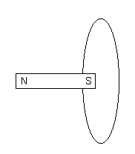

2) The magnet is moved away from the wire. Would there be a current through the loop, while the magnet is being moved away from the wire? If so, which direction would the current flow? Explain.

