UNIT 12 PRETEST

1) Consider the circuit shown below, consisting of battery, switch, capacitor, and resistor.

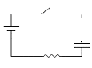

Describe the current through the resistor as a function of time when the switch is closed. Explain.

