UNIT 11 PRETEST

1) Consider the diagram below.

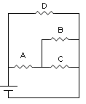

Suppose the current through resistor A is 1.5A, resistor B is 2.5A, and battery voltage is 1.5V. Find the resistance of each of the resistors: A, B, C, and D.

