UNIT 10 PRETEST

1) Consider the circuit shown below.

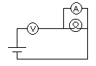

a. Is the ammeter connected correctly to measure the current through the bulb. Explain.

b. Is the voltmeter connected correctly to measure the voltage across the battery.

2) Consider the circuit shown below.

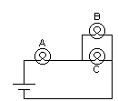

a. If a voltmeter connected across bulb B reads 0.5 volts, what is the voltage across bulb A (assume a 1.5V battery)?

b. If a voltmeter connected across bulb B reads 0.5 volts, what is the voltage across bulb C (assume a 1.5V battery)?

