UNIT 9 PRETEST

1) Consider the diagram below.

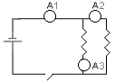

If the ammeter 1 reads 2.5 amps, and the nichrome wires are the same length what would ammeters 2 and 3 read? Explain your reasoning.

