UNIT 8 PRETEST

1) Consider the following circuits.

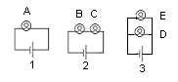
a) The bulbs are labeled A-E. Rank the brightness of the bulbs. Explain your reasoning.

b) The batteries are labeled 1-3. Rank the current through the batteries. Explain your reasoning.

