UNIT 6 PRETEST

1) Consider the following diagram.

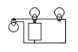

a) Draw a standard circuit diagram.

b) Do all the bulbs light? Explain your reasoning

