UNIT 1 PRETEST

1) Consider the following hypothetical experiment:

There are two kinds of balls on a table, red and green. Serena experimented with them, and found the following:

red balls are attracted to red balls
green balls are attracted to green balls
red balls repel green balls

Then she spray painted all the balls silver.

i) Her sister then experimented with the balls. What observations could she make?

What might she infer, based on her observations?

ii) Suppose there were a third kind of ball (yellow), distinctly different from Serena’s red and green balls, based on the way it interacted with red and green balls. How would it interact with red balls? How would it interact with green balls? How would it interact with other balls of the same kind? Explain your reasoning.

2) Choose one or more answers to the following question and explain the reason for your choice of answers.

The effect seen in the picture below, can be explained by modeling the man as a big

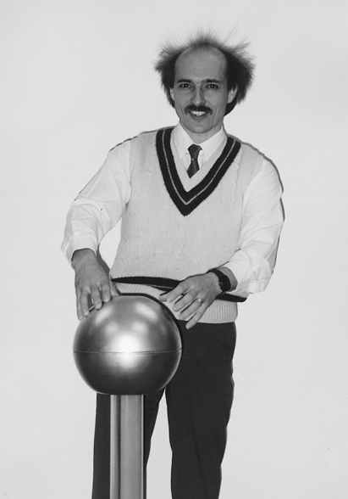
a) conductor

b) insulator

c) semi-conductor

d) resistor

e) another answer

