UNIT 17
FORCES ON CHARGES IN MAGNETIC FIELDS

Objectives

- to understand the magnitude and direction of the force on a charged particle in a magnetic field qualitatively and quantitatively

- to be able to apply knowledge of magnetic fields and forces to applications used in industry and everyday life

Equipment:
None

1.1

a. If a single charged particle were in a magnetic field, would it experience a force? (You may wish to refer to the discussion in part 1.1 in Unit 15) Consider two cases: 1) the charge is moving 2) the charge is at rest. Explain your reasoning.

Discuss with an instructor.

b. Suppose a positively charged particle entered a magnetic field as in the diagram below. When it first entered the field, which direction would the force be?

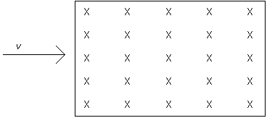

c. As the particle continued to move through the field, would it change direction? Would the force on it change direction? Draw the path of a particle moving through the magnetic field shown. Explain why you drew the path the way you drew it. Draw the magnetic force on the particle at different points along the path. Explain why you drew the force the way you did.

The magnitude of the force on a charged particle in a magnetic field is given by

,

where q is the charge of the particle, v is the velocity of the particle and B is the magnitude of the magnetic field.

The direction of the force on a positive charge is given by the same right hand rule as for the direction of the force on a current-carrying wire in a magnetic field, with the direction of the velocity substituting for the direction of the current. For a negative charge, the force is in the opposite direction.

d. Are your answers to parts b and c consistent with the equation and right hand rule for the force on a charged particle?

Discuss your answers with an instructor.

Equipment:
None

2.1

a. Write a general equation for the force on a particle moving at constant velocity in a circle.

b. If particles of the same charge, but different masses were sent at constant velocity v into a magnetic field B, would they all follow the same path? Use the equation in part a and the fact that the force on a charged particle moving at constant velocity in a magnetic field is given by to answer this question.

A mass spectrometer is a machine that separates particles of the same charge that have different masses by sending them at constant velocity into a magnetic field.

3.1

Consider the following machine. It consists of two half-circles with a gap between them. There is an electric field upwards in the gap and a magnetic field into the page everywhere in each of the two circular halves.
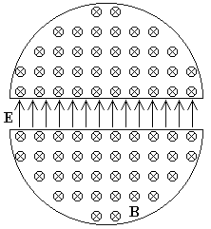

a. A positively charged particle started near the center of the machine would accelerate in the direction of the electric field. Describe the motion of the particle over a long period of time. (There is no electric field in each of the two circular halves.)

Discuss the path of the particle with an instructor.

The machine described above is called a cyclotron. It is a machine used to accelerate charged particles to very high speeds. The particles are then used for many medical applications, like producing radioactive particles for diagnosis and treatment and isotopes for imaging techniques.

SUMMARY

You should understand the magnitude and direction of the force on a charged particle in a magnetic field qualitatively and quantitatively. You should be able to apply knowledge of magnetic fields and forces to applications used in industry and everyday life.

