UNIT 16
FARADAY’S LAW AND LENZ’S LAW

Objectives

- to understand how a changing magnetic field can give rise to a current

- to understand the concept of magnetic flux

- to understand qualitatively and quantitatively (Faraday’s Law) that a changing magnetic flux gives rise to an emf

- to understand the direction of a current set up by a changing magnetic field (Lenz’s Law)

Equipment:
1 cow magnet
1 spool of magnet wire
1 analog ammeter

1.1

Connect a wire formed into many loops to an analog ammeter, as shown in the diagram below.

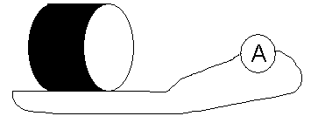

a. Take a cow magnet and move it back and forth near the loops of wire. Observe the ammeter while the magnet is moving.

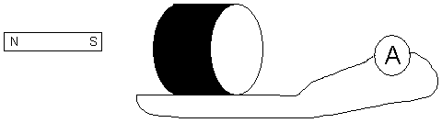

Put the north pole toward the loop. Then put the south pole toward the loop. Record your observations.

b. Hold the magnet still near the loops of wire. Record your observations.

c. Repeat part a. Determine the direction of flow of positive charge through the wire based on the ammeter reading for each case:

- north pole moves toward the loops
- north pole moves away from the loops
- south pole moves toward the loops
- south pole moves away from the loops

d. There is no battery in the circuit. Yet, charges are moving through the wire. There must be a force doing work on the charges. Further experiments show that the charges are moving because they are in an electric field. The changing magnetic field is creating an electric field. The work done per unit charge by the electric force is called the emf, E. If more work is done per unit charge, the current is larger. The emf and the current are related by E = IR.

The rate at which charges move through the wire seems to depend on the motion of the magnet. Further experiments (which we will not do) reveal that the amount of current in the wire depends on:

- the time rate of change of magnetic flux
- the number of loops (turns) in the wire

The magnetic flux is defined the same way as the electric flux, but in terms of the magnetic field and the area, instead of the electric field and the area:

$$Φ=\text{BA}\text{cos}θ$$

The equation for the emf for a wire with N turns is then:

$$E=−N\frac{\text{ΔΦ}}{Δt}$$

where N is the number of turns in the wire, $\frac{\text{ΔΦ}}{Δt}$ is the time rate of change of magnetic flux. This equation is called Faraday’s Law.

The direction the current flows through the loop is such that the current in the loop will set up a magnetic field to oppose the change in flux through the loop. This is called Lenz’s Law.

If the north pole of the magnet is moving toward the loop, the flux through the loop is increasing, the current through the loop would set up a magnetic field in the opposite direction as the magnetic field produced by the north pole of the magnet in order to decrease the flux through the loop.

If the north pole of the magnet is moving away from the loop, the flux through the loop is decreasing, the current through the loop would set up a magnetic field in the same direction as the magnetic field produced by the north pole of the magnet in order to increase the flux through the loop.

e. Determine the direction that current flows through the loop when the south pole of the magnet moves toward the loop and when the south pole of the magnet is moved away from the loop.

Discuss part e with an instructor.

SUMMARY

You should understand that a changing magnetic field can give rise to a current. You should also understand the concept of magnetic flux. You should understand qualitatively and quantitatively (Faraday’s Law) that a changing magnetic flux gives rise to an emf. You should understand the direction of a current set up by a changing magnetic field (Lenz’s Law).

