UNIT 15
FORCES ON CURRENT-CARRYING WIRES IN MAGNETIC FIELDS

Objectives

- to understand the magnitude and direction of the force on a current-carrying wire in a magnetic field

- to use the concepts of magnetic fields and magnetic forces to understand how a simple motor works

Equipment:
1 two-wire setup
1 permanent magnet
4 paper clips
1 rod stand
1 rod
1 wood rod
1 switch
1 battery
1 battery holder
6 wire with alligator clips
1 wire with both ends stripped

1.1 If a current-carrying wire gives rise to a magnetic field, is it possible that a magnetic field has an effect on a current-carrying wire?

a. Observe what happens when two wires carrying current are placed near each other. Ask an instructor for the setup. Observe the interaction when

i) the currents are in the same direction

ii) the currents are in the opposite direction

b. Consider two wires with currents in the same direction.

(i) In the diagram below, draw the direction of the magnetic field due to wire 1 at wire 2, and the direction of the force on wire 2 due to wire 1.

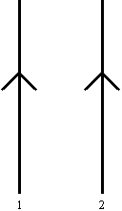

(ii) In the diagram below, draw the direction of the magnetic field due to wire 2 at wire 1, and the direction of the force on wire 1 due to wire 2.

c. Consider two wires with currents in the opposite direction.

(i) In the diagram below, draw the direction of the magnetic field due to wire 1 at wire 2, and the direction of the force on wire 2 due to wire 1.

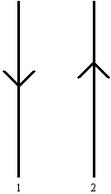

(ii) In the diagram below, draw the direction of the magnetic field due to wire 2 at wire 1, and the direction of the force on wire 1 due to wire 2.

1.2 Set up the setup shown below.

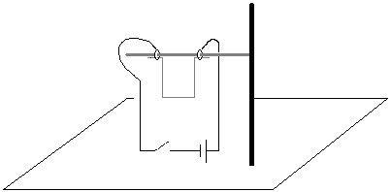

a. Bring the north pole of a magnet up under the wire, as in the diagram below. Observe the motion of the wire when the switch is closed.

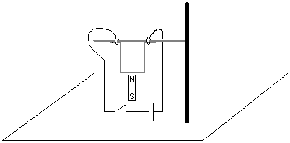

b. Bring the south pole of a magnet up under the wire. Observe the motion of the wire when the switch is closed.

c. Switch the direction of the battery. Repeat parts a and b.

d. In each of the cases in parts a through c above, draw the direction of positive charge through the wire, the direction of the magnetic field near the wire and the direction of the force on the wire.

f. Try to come up with a rule for determining the direction of the force on a current-carrying wire in a magnetic field.

Check your rule with an instructor.

The magnitude of the force is given by

$F=\text{IlB}\text{sin}θ$

where I is the amount of current through the wire, l is the length of the wire, B is the magnitude of the magnetic field and θ is the angle between the magnetic field and the current. The magnetic field is measured in units of Tesla. The symbol for Tesla is T.

The direction of the force is given by a right hand rule. Place your thumb in the direction of the current, I, point your fingers in the direction of the magnetic field, B, and the direction of the force is pointing away from your palm, as shown in the picture below.

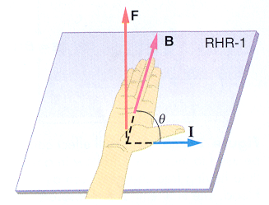
(from College Physics by Paul Peter Urone, Brooks/Cole Publishing Company, NY, 1998

Equipment:
2 paper clips
1 square magnets
1 battery
1 wire with both ends stripped
magnet wire
1 styrofoam cup
1 roll of masking tape

2.1

Construct a small motor, as in the picture below. The loop consists of magnet wire, with the ends half stripped, as in the second picture.

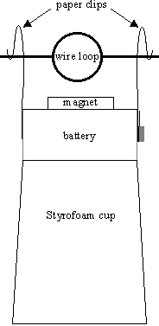

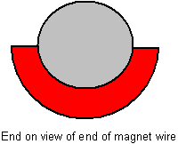

Explain why the motor works.

Explain why the motor does not work when the wire is fully stripped.

SUMMARY

You should understand the magnitude and direction of the force on a current-carrying wire in a magnetic field. To understand how a simple motor works.

