UNIT 14
MAGNETIC FIELDS
(from Lillian C. McDermott, Peter S. Shaffer and the Physics Education Group, Tutorials in Introductory Physics (Homework), Prentice Hall, NJ, 1998)

Objectives

- to understand the nature of a magnetic field

- to be able to represent a magnetic field at a point with a vector

- to understand how to represent a magnetic field with field lines

- to understand that a current gives rise to a magnetic field

- to be able to determine the direction of the magnetic field due to a current-carrying wire

Equipment:
1 permanent magnet
1 sheet of paper
1 container of iron filings
6 small compasses
10-12 square stack magnets

1.1 Place a bar magnet on the table as in the diagram below.

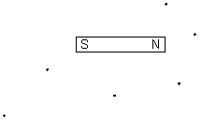

a. Place a compass at each point shown on the diagram. Draw an arrow on the diagram indicating the direction that the north end of each compass points.

b. Place a piece of paper on top of the magnet and sprinkle iron filings on the paper.

The motion of the compasses and the alignment of the iron filings give us the idea that there is a quantity with a magnitude and a direction at each point in space that determines the motion of the compasses. We will call this a magnetic field. We will rigorously define a magnetic field later. We will choose the direction that the north end of each compass points as the direction of the magnetic field.

c. On the diagram below draw a vector at each of the points that indicates the magnitude of the magnetic field at that point.

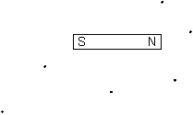

1.2 Obtain a stack of small magnets and place them as in the diagram below.

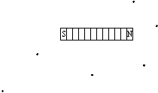

a. Draw the magnetic field vectors at each of the points.

b. Remove the left half of the stack as in the diagram below.

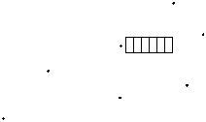

Draw the magnetic field vectors at each of the points in the diagram above.

c. Replace the left half and remove the right half as in the diagram below.

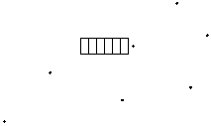

Draw the magnetic field vectors at each of the points in the diagram above.

d. Compare the field vectors for the two halves to that of the whole. Is your observation consistent with the idea that magnetic fields obey the principle of superposition? Explain.

e. What is the direction of the magnetic field in the center of a magnet? Explain.

Equipment:
1 container of iron filings
6 small compasses
1 rod stand
1 rod
1 square piece of cardboard
1 switch
1 battery
1 battery holder
6 wires with alligator clips
1 single loop setup

2.1 Consider the set up of a circuit, consisting of a wire, switch, and battery, as in the diagram below. The wire passes through hole in a piece of cardboard that is supported by a rod stand. Compasses are placed around the wire on the sheet of cardboard.

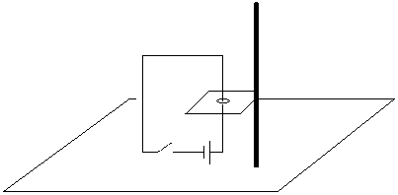

a. Predict what would happen to the compasses, if the switch were closed.

b. Ask an instructor to show you an experimental set up similar to the one above. Observe what happens to the compasses, if the switch is briefly closed.

c. Turn the battery around. Again close the switch and observe what happens, as in
part b.

d. Based on your knowledge of compasses, is there a magnetic field near the wire

(i) when the switch is closed?

(ii) when the switch is open?

Explain your reasoning. If there is a field, describe approximately its magnitude and its direction at different points around the wire.

e. If you were to place iron filings around the wire, what would happen?

f. Test your prediction in part e.

2.2

a. If you were to bend the wire into a loop, and place iron filings in a plane through the center of the loop, what, if anything, would happen? Explain.

b. Ask an instructor to show you the experimental set up with a wire bent into a loop and test your predictions.

c. Draw the direction of the magnetic field in each of the four pictures below. Use the following convention:

- If the magnetic field is out of the page, symbolize it as

- If the magnetic field is into of the page, symbolize it as $⊗$

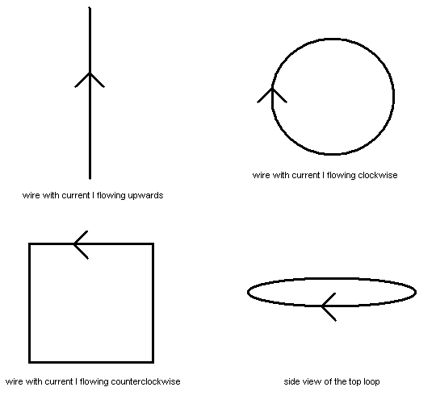

Check your drawings with an instructor.

A right hand rule is often used to indicate the direction of the field of a current-carrying wire. Put your thumb in the direction that positive charges would travel through the wire. Your fingers will curl in the direction of the magnetic field.

2.3

a. Suppose you wrapped a current-carrying wire around a cylinder, as in the picture below. What would be the approximate magnitude and direction of the magnetic field at the points shown? Draw the magnetic field lines in the picture.

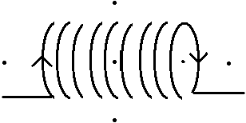
This figure is called a solenoid.

b. Ask an instructor to show you the experimental set up with a solenoid to test your predictions.

c. How does the magnitude of the field inside the solenoid compare to the magnitude of the field outside the solenoid? Explain your reasoning.

SUMMARY

You should understand the nature of a magnetic field. You should be able to represent a magnetic field at a point with a vector. You should understand how to represent a magnetic field with field lines. You should understand that a current gives rise to a magnetic field. You should be able to determine the direction of the magnetic field due to a current-carrying wire.

