Homework 5
PHYS 1404
due February 26, 2004

Homework should be written out neatly on a separate sheet of paper. Explain your reasoning.

1) Consider a negatively charged particle entering a region between two charged plates, as shown in the diagram below. The initial velocity of the particle is 7.0 × 10⁷ m/s. The mass of the particle is 9.1 × 10⁻³¹kg and the charge is -1.6 × 10⁻¹⁹C. The distance between the plates is 0.025m. You can consider the electrical force to be the only force acting between the plates. (The force of gravity is negligible and can be considered to be zero in this problem.) The magnitude of the electric field is such that the particle just reaches the negative plate (the velocity at the negative plate is zero), as in Homework 3.

a) Determine the potential difference between the plates. Show your work and explain your reasoning.

b) Which plate is at a higher potential. Show your work and explain your reasoning.

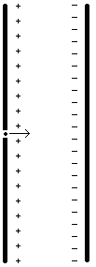
2)

a) Each of the two diagrams below shows some charges and an insulating spherical shell. In each of the two diagrams determine,

(i) if the potential at point i is equal, greater than or less than the potential at point f. Explain your reasoning.

(ii) if the electric field at point i is equal, greater than or less than the electric field at point f. Explain your reasoning.

(iii) if the flux through the sphere is positive, negative or zero. Explain your reasoning.

a)

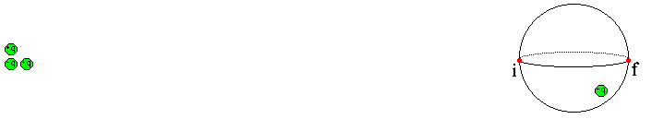

b)

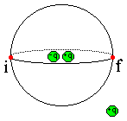

3) Consider the three diagrams below. In each diagram, point i and point f indicate two locations.

(i)

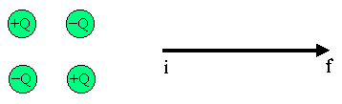

(ii)

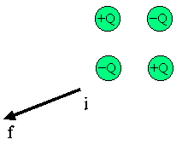

(iii)



a) In each diagram, determine if the work done by the electric field in moving a negative charge from point i to point f is positive, negative or zero. Show your work and explain.

b) In each diagram, determine if the potential is greater at point i or point f. Determine if the quantity $ΔV=V_{f}−V_{i}$ is positive, negative or zero. Explain.

