Homework 4
PHYS 1404
due February 19, 2004

Homework should be written out neatly on a separate sheet of paper. Explain your reasoning.

1) A rectangular box 0.04m x 0.04m x 0.06m is located in a uniform electric field of magnitude 580 N/C. Which orientation of the box would give the maximum flux through one of the square surfaces of the box? Which orientation of the box would give the maximum flux through one of the rectangular surfaces of the box? What is the net flux through the box? Show your work and explain your reasoning.

2)

a) A rectangular surface of dimensions 0.04m x 0.07m lies in a uniform electric field of magnitude 182 N/C at an angle of 55 degrees to the plane of the surface. Calculate the electric flux on the surface. Show your work and explain your reasoning.

b) Consider a box on whose surfaces the electric field is measured to be horizontal and to the right. On the left face (0.06m by 0.02m) the magnitude of the electric field is 145 N/C, and on the right face the magnitude of the electric field is 870 N/C.

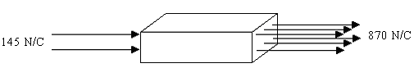

i) Calculate the electric flux on every face of the box.

ii) Calculate the total flux of the box.

iii) Calculate the total amount of charge that is inside the box.

3) Consider the following enclosed surfaces. A positive charge q = 3.2×10⁻⁶C is placed inside the spheres as shown. Determine the net flux through each sphere. Show your work and explain your reasoning.

