Homework 2
PHYS 1404
due February 5, 2004

Homework should be written out neatly on a separate sheet of paper. Explain your reasoning.

1) Four identical conducting balls, A, B, C and D, are placed on insulating stands. Ball A has a net charge of +Q, B has a net charge of –Q and C and D are neutral. Ball C is first brought in contact with ball A and then removed from contact. Then, without discharging Ball C, it is brought in contact with ball B and then removed from contact.

a) What is the final charge state of each ball? Explain your reasoning.

b) If the charged balls are now brought near but not touching each other two by two, and the balls are held the same distance apart in each case, rank the following forces:

F_{AB} force of ball A on ball B F_{BA} force of ball B on ball A
F_{BC} force of ball B on ball C F_{CB} force of ball C on ball B
F_{AD} force of ball A on ball D F_{DA} force of ball D on ball A

Explain your reasoning.

2) A large charged metal plate is lying horizontally, as in the picture below. A -2C positive charge is located 0.20m above the plate, as shown.

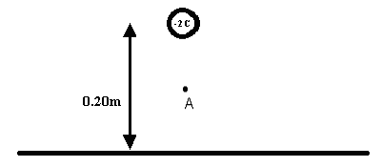
Point A is halfway between the center of the -2C charge and the plate. If the net electric field is zero at point A, what is the magnitude and direction of the field at point A due to the charged plate? What is the sign of the charge on the plate? Show your work.

3) Two identical pith balls are hung by insulating strings, touching each other, as in the picture below. The mass of each ball is 0.002kg. The strings are 28cm long.

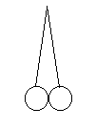
The two balls, while touching each other, are touched simultaneously to a charged rod. After they are touched by the rod, they move apart. The angle between the strings is eight degrees, as shown in the diagram below.

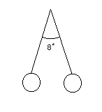
Determine the charge on each ball. Show your work and explain your reasoning.

