UNIT 19 EXERCISES

1) In the classroom is a mirror attached to the wall. Stand 1.2m from the mirror and observe how much of yourself you can see in the mirror. Walk back to 5.5m from the mirror. How much of yourself can you see in the mirror? How much of yourself can you see in the mirror at other distances? Explain.

2) A pinhole camera can be made by creating a nail hole in a shoebox and inserting an eyepiece in the shoebox as in the picture below.

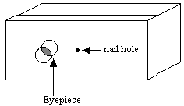

Obtain a pinhole camera. Inside, look at bright lights or a window through the camera. Outside on a sunny day, look at trees, buildings, and people through the camera.

Describe the image. Is it right side up, reversed or left to right? Explain (using ray diagrams).

How does the size of the image compare to the object? Explain.

How could you use the camera to record an image on film? Explain.

3) Design a microscope that magnifies 50 times. What focal length lenses would you use? How far apart would you place the lenses? Explain. Could you design a microscope that would magnify 50 or 100 times by changing one of the lenses?

