UNIT 17 EXERCISES

1) A particle in the Earth’s atmosphere has a charge of $q=1\text{.}6×{\text{10}}^{−\text{19}}C$ and a velocity of $v=7\text{.}\text{50}×{\text{10}}^{6}m/s$ perpendicular to the Earth’s magnetic field at an altitude where the magnitude of the magnetic field is $1\text{.}0×{\text{10}}^{−5}T$. What is the radius of the path the electron follows? Show your work.

2) Consider the diagram below. It consists of two capacitor plates with positive charges on the bottom plate and negative charges on the top plate. There is an electric field pointing upwards and a magnetic field pointing out of the page everywhere in between the plates.

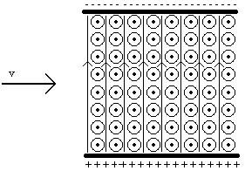

a) What is the magnitude and direction of the electric force on a particle of charge +q and velocity v that enters the region between the plates? Explain.

b) What is the magnitude and direction of the magnetic force on a particle of charge +q and velocity v that enters the region between the plates? Explain.

c) Could these forces be arranged so that a particle would pass through in a straight line? Explain. If so, how would the magnitudes of the electric and magnetic forces be related? Does this depend on the velocity of the particle? Explain.

d) Could the magnitude of the electric and magnetic fields be chosen so that only particles with a certain velocity, v, would go straight through? Explain.

e) If the electric and magnetic fields were chosen so only particles with a certain velocity, v, pass through in a straight line, what would happen to particles that had a velocity larger than v? Explain. What would happen to particles that had a velocity smaller than v? Explain.

f) Would any of your above answers change if the particle were negatively charged? Explain.

g) Could this be called a velocity selector? Explain.
3) In a TV or computer monitor charged particles are accelerated and then passed through a series of electric fields that direct them to different parts of the screen. This is illustrated in the picture below, where the different sets of parallel plates are capacitors.

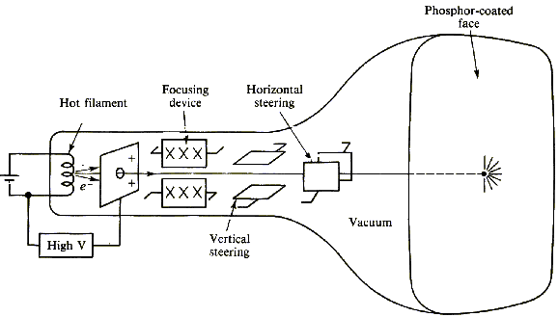
(from Physics With Health Science Application, Paul Peter Urone, John Wiley and Sons, Inc., NY, 1986)

What happens when a magnet is brought near the TV or monitor? (Don’t do this at home or in the lab, as it may damage the TV or computer.) Is the picture changed? Explain.

