UNIT 16 EXERCISES

1) Consider a U-shaped metal rod with a metal rod touching it, which is free to slide (shown below). A magnetic field is into the page everywhere, as in the diagram.

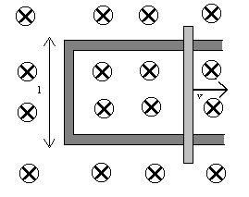

If the rod is moving to the right at a velocity v,

(i) would there be a current? Explain. If so, determine the direction of the current.

(ii) would there be an emf? Explain. If so, calculate the emf in terms of the magnetic field, B, the velocity of the rod, v, and the length l.

2) (from Arnold B. Arons, Homework and Test Question for Introductory Physics Teaching, John Wiley and Sons, Inc., NY, 1994.)

Two solenoids 1 and 2 are sufficiently close together that the magnetic field formed in solenoid 1, in the presence of electric current, also penetrates into solenoid 2.

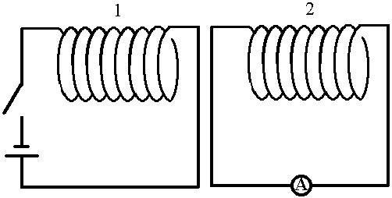

a) If the switch closed so that a steady current is present in solenoid 1, what is the direction of the magnetic field in solenoid 2? Show its direction by means of an arrow in the diagram. Explain your result. If the B-field is zero, say so explicitly and explain your reasoning.
b) If the switch is now opened, and the current in solenoid 1 drops to zero, describe what, if anything, happens in solenoid 2, showing the direction of any current induced in solenoid 2. Explain your reasoning. Is there a current in solenoid 2 after the current in solenoid 1 has dropped to zero? Explain your reasoning.

3) (from Arnold B. Arons, Homework and Test Question for Introductory Physics Teaching, John Wiley and Sons, Inc., NY, 1994.)

The diagram shows a circuit with a variable resistor on the right and a closed wire loop on the left.

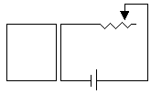

Suppose the lead is slid to the right, increasing the resistance. Will there be a current induced in the wire loop on the left? If so, in what direction? If not, why not? Explain your reasoning.

