UNIT 15 EXERCISES

1) A magnet is placed near a current carrying wire as in the diagram below.

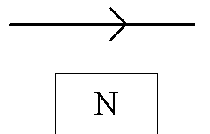

Determine the direction of the force on the wire.

2) (from Arnold B. Arons, Homework and Test Question for Introductory Physics Teaching, John Wiley and Sons, Inc., NY, 1994.)

Two wires lie perpendicular to the plane of the paper and carry equal electric currents in the direction shown. Point P is equidistant from the two wires.

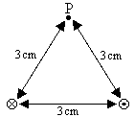

a) Construct a vector diagram showing the net magnetic field vector at point P. Explain your reasoning.

b) Suppose a third wire carrying equal current into the plane of the paper were located at P. What would be the direction of the force on this wire? Explain your reasoning.

c) If the distance between each of wires is 3cm, as shown in the diagram, and the current through each of the two wires shown in the diagram and a third wire placed at P is 2A,

(i) calculate the magnitude of the net magnetic field at point P. Show your work.

(ii) calculate the magnitude of the force on the wire placed at point P. Show your work.

3) In the region shown in the diagram below, there is a constant magnetic field to the right in the plane of the paper. The magnitude of the magnetic field is $B=1\text{.}4×{\text{10}}^{−5}T$. A wire with current $I=1\text{.}2×{\text{10}}^{−2}A$ lies in the magnetic field as shown in the diagram. The direction of the current is out of the page.

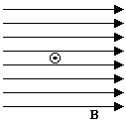

Determine the magnitude and direction of the force on the wire. Show your work.

