UNIT 14 EXERCISES

1) Draw the magnetic field lines for the bar magnet shown in the diagram below.

2) Draw the magnetic field lines for the wire shown in the diagram below.

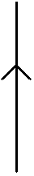

3) (from Lillian C. McDermontt, Peter S. Shaffer and the Physics Education Group, Tutorials in Introductory Physics, Prentice Hall, NJ, 1998.)

The diagram below shows magnetic field lines near some magnets. Only a small region is shown.

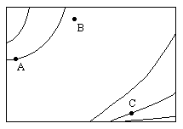

Rank the magnitude of the magnetic field at points A, B, and C. Explain your ranking. If you cannot rank the magnetic field at some of the points, explain why you cannot.

4) (from Lillian C. McDermontt, Peter S. Shaffer and the Physics Education Group, Tutorials in Introductory Physics, Prentice Hall, NJ, 1998.)

The diagram below shows magnetic field lines near some magnets. Only a small region is shown.

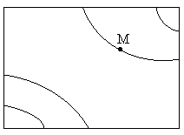

Indicate the direction of the magnetic field at point M. Explain how you know the direction. If the direction cannot be determined, explain why not.

