UNIT 13 EXERCISES

1) (from Lillian C. McDermontt, Peter S. Shaffer and the Physics Education Group, Tutorials in Introductory Physics, Prentice Hall, NJ, 1998.)

A student is studying the behavior of three objects. She labels the objects 1,2, and 3 and places red (R) and blue (B) stickers on either end of each object as shown below.

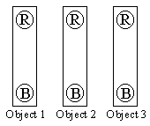

She finds that:

(i) the end 1R attracts the end 2R

(ii) the end 2R attracts the end 3B

(iii) object 1 and object 3 do not interact

Classify the three objects as magnets, ferromagnets, or non-magnetic objects. Explain your reasoning. If you cannot classify some of the objects on the basis of the information given above, explain why not and describe experiments you could perform to help you classify the objects.

2) (from Lillian C. McDermontt, Peter S. Shaffer and the Physics Education Group, Tutorials in Introductory Physics, Prentice Hall, NJ, 1998.)

Consider four metal bars as in the diagram below. The bars are numbered 1 through 4. The ends of each bar are labeled A and B, and the middle of each bar is labeled m.

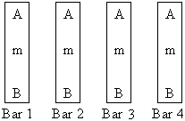

Assume that any objects that are magnets have their poles on the ends A and B.

A student makes the following observations:

(i) 1A attracts 2A

(ii) 1A does not interact with 3m

(iii) 1A repels 4B

a) Classify the three objects as magnets, ferromagnets, or non-magnetic objects. Explain your reasoning. If you cannot classify some of the objects on the basis of the information given above, explain why not and describe experiments you could perform to help you classify the objects.

b) How would 1A interact if it were brought near 4m? If it is possible to tell, what are the possibilities? Explain.

3) A small compass is placed near a very large piece of ferromagnetic material.

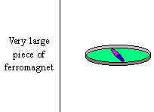

Before the compass is placed near the material, it is pointing toward the Earth’s geographic north.

Would the compass needle move? Explain your reasoning. If so, what direction would it point? Explain your reasoning.

4) Why does a magnet stick to a refrigerator? Explain your reasoning.

