UNIT 10 EXERCISES

1) Consider the following circuit.

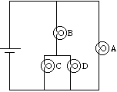

a) If bulb D were removed from the circuit, would the potential difference across

(i) bulb A increase, decrease or remain the same? Explain your reasoning.

(ii) bulb B increase, decrease or remain the same? Explain your reasoning.

(iii) bulb C increase, decrease or remain the same? Explain your reasoning.

b) If a wire were added to the circuit as shown in the diagram below,

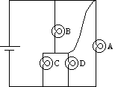

would the potential difference across

(i) bulb A increase, decrease or remain the same? Explain your reasoning.

(ii) bulb B increase, decrease or remain the same? Explain your reasoning.

(iii) bulb C increase, decrease or remain the same? Explain your reasoning.

2) Consider the circuit below consisting of two nichrome wires in series.

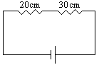

a) If the battery voltage is 1.5V, determine the voltage across each of the nichrome wires. Explain.

b) If the 30cm wire were replaced by a 40cm wire, determine the voltage across each of the nichrome wires. Explain.

c) Return to the original circuit. If the 20cm wire were replaced by a 40cm wire, determine the voltage across each of the nichrome wires. Explain.

3) Consider the circuit below.

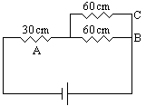

a) If the battery voltage is 1.5V, determine the voltage across each of the nichrome wires. Explain.

b) If a 30cm length of nicrome wire were added the circuit as in the diagram below,
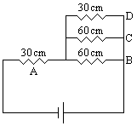

(i) would the voltage across resister A increase, decrease, or remain the same? Explain.

(ii) would the voltage across resister B increase, decrease, or remain the same? Explain.

