UNIT 9 EXERCISES

1) An ammeter must be placed in a circuit in such a way that the current through the circuit is not changed very much. Does an ammeter have a very high resistance or a very low resistance? Explain.

2) (from Lillian C. McDermontt and the Physics Education Group, Physics by Inquiry Volume II, John Wiley and Sons, NY, 1996.)

Consider the circuit in the picture below.

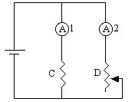

a) Nichrome wire D is a variable length wire. Wire D can be set to any length.

How would the reading of ammeter A1 compare to the reading of ammeter A2, if

(i) wire D is longer than wire C? Explain.

(ii) wire D is shorter than wire C? Explain.

(iii) wire D is the same length as wire C? Explain.

b) How could a circuit similar to the one above be used to determine an unknown resistance? For example, suppose you had a black box with two wires sticking out that you could connect to a circuit. You know there is some resistance inside the box, but you do not know how much. How could you determine the resistance? Explain.

c) (i) Using the method in part b it is possible to determine approximately (there will be some error in the measurement) the resistance of a network of resistors. Determine the resistance of the following networks.

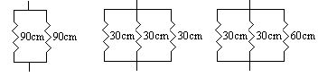

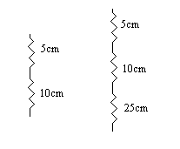

(ii) Try to come up with a mathematical rule for determining the resistance of a series network.

(iii) Try to come up with a mathematical rule for determining the resistance of a parallel network.

3) Consider the two circuits below.
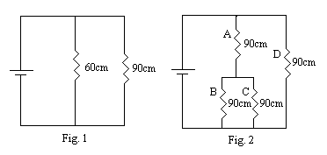
a) Rank the current through each of the wires in Fig. 1. Explain your reasoning.

b) Rank the current through each of the wires in Fig. 2. Explain your reasoning.

c) In Fig. 1, if a total current i flows through the battery, what fraction of that current flows through each resistor? Show your work.

