UNIT 8 EXERCISES

1) (from Lillian C. McDermontt and the Physics Education Group, Physics by Inquiry Volume II, John Wiley and Sons, NY, 1996.)

Rank the current through the battery for each of the following circuits. Explain your reasoning.

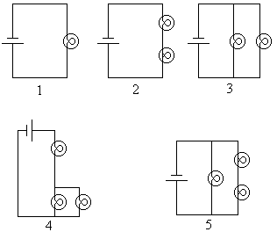

2) Consider the following circuit.

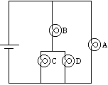

a) If bulb D were removed from the circuit, would the current through

(i) bulb A increase, decrease or remain the same? Explain your reasoning.

(ii) bulb B increase, decrease or remain the same? Explain your reasoning.

(iii) the battery increase, decrease or remain the same? Explain your reasoning.

b) If a wire were added to the circuit as shown in the diagram below,

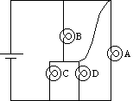

would the current through

(i) bulb A increase, decrease or remain the same? Explain your reasoning.

(ii) bulb B increase, decrease or remain the same? Explain your reasoning.

(iii) the battery increase, decrease or remain the same? Explain your reasoning.

3) (from Lillian C. McDermontt and the Physics Education Group, Physics by Inquiry Volume II, John Wiley and Sons, NY, 1996.)

Below is a diagram showing a typical household circuit. The appliances (lights, television, toaster, ect.) are represented by boxes labeled 1, 2, 3, and so on.

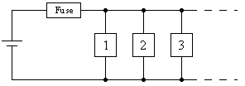

A fuse or circuit breaker is intended to shut off the circuit if the wires in the circuit get hot enough to pose a threat of fire. The wires in a circuit (which in a house are in the walls) are hotter when more current is flowing through them. A fuse or circuit breaker is sensitive to the amount of current passing through it. A fuse will heat up and burn out (melt) when too large a current flows through it. A circuit breaker will open a switch and break the circuit when too large a current flows.

What happens to the current through the fuse in the circuit above when more appliances are added to the circuit? Explain.

