UNIT 6 EXERCISES

1) Draw a standard circuit diagram for each of the following diagrams:

(i)
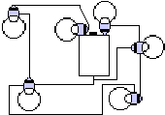

(ii)
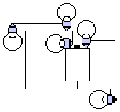

(iii)
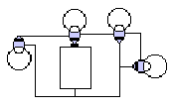

2) Set up the following circuits.

(i)
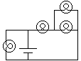

(ii)
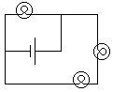

(iii)

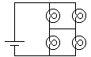

3) (from Lillian C. McDermontt and the Physics Education Group, Physics by Inquiry Volume II, John Wiley and Sons, NY, 1996.)

Using a battery, a holder, a bulb, a socket, and two wires, set up a circuit that lights the bulb. Draw a sketch of the circuit in which you trace the path of the conductors around the circuit, including in detail the conducting path through the different parts: the battery holder, bulb, socket, and switch.

