UNIT 4 EXERCISES

1) Consider the following boxes. The electric field vectors at the surface of the box are shown.

Determine if there is a net flux through each box. Determine if there is charge inside each box. Explain how you know.

(a)
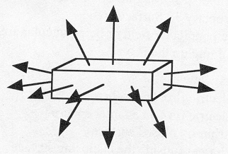

(b)
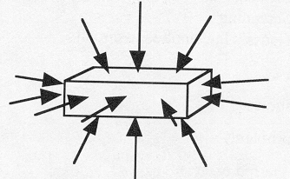

(c)
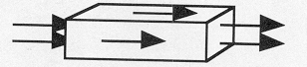
(pictures from Ruth Chabay and Bruce Sherwood, Electric and Magnetic Interactions, John, Wiley, and Sons Inc., NY, 1995)

2) (from Ruth Chabay and Bruce Sherwood, Electric and Magnetic Interactions, John, Wiley, and Sons Inc., NY, 1995)
Here is a disk-shaped region of radius 2cm, on which there is a uniform electric field of magnitude 300 N/C at an angle of 30 degrees to the plane of the disk. Calculate the electric flux on the disk, and include the correct units.

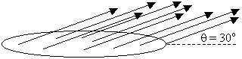

3) (from Ruth Chabay and Bruce Sherwood, Electric and Magnetic Interactions, John, Wiley, and Sons Inc., NY, 1995)
Here is a box on whose surfaces the electric field is measured to be horizontal and to the right. On the left face (3cm by 2cm) the magnitude of the electric field is 400 N/C, and on the right face the magnitude of the electric field is 1200 N/C.

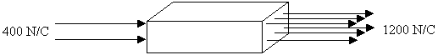

a) Calculate the electric flux on every face of the box.

b) Calculate the total flux of the box.

c) Calculate the total amount of charge that is inside the box.

