UNIT 1 EXERCISES
1) (from Ruth Chabay and Bruce Sherwood, Electric and Magnetic Interactions, John, Wiley, and Sons Inc., NY, 1995)

Consider a piece of aluminum foil near a negatively charged pen, as in the picture below. While the pen is near the foil, you touch the foil, then remove your finger. Then remove the pen.

The “comic strip” below illustrates the process. Draw other relevant charges, and explain the motion of charges in each frame.
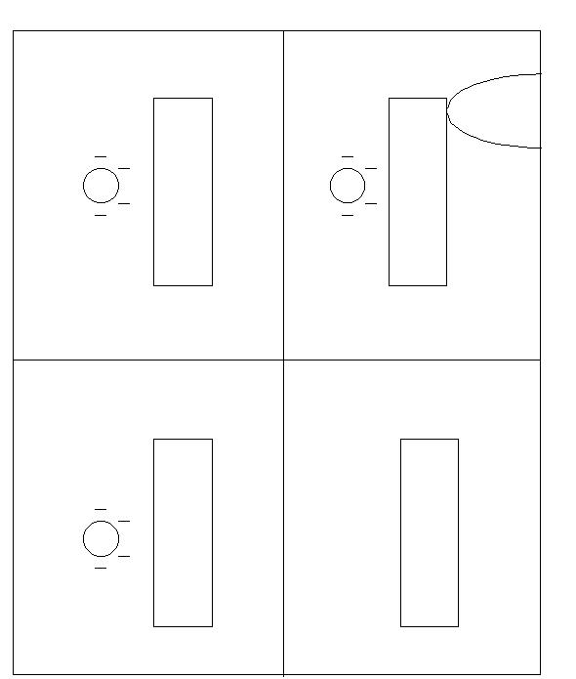
2) A Van de Graaff generator is a machine that is designed to deposit a large amount of charge on a sphere. When the Van de Graaff generator is turned on, charge builds up on the sphere. You may observe the Van de Graaff generator in class. Explain what happens to the man’s hair when the Van de Graaff generator is turned on.

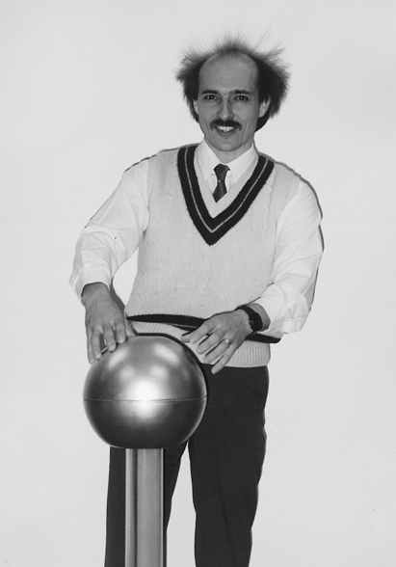
(Priscilla W. Laws, Workshop Physics Activity Guide, John Wiley & Sons, Inc., New York, 1999)

3) (from Arnold B. Arons, Homework and Test Question for Introductory Physics Teaching, John Wiley and Sons, Inc., NY, 1994.)

To metal cans are placed near each other on a table as shown in the picture below. A pith ball on a non-conducting string is suspended so that is hangs between the two cans. One of the cans is now charged positively charged rod. The pith ball is attracted to the charged can, makes contact, swings over to the other can, makes contact, flies off, and then continues to oscillate back and forth between the two cans.

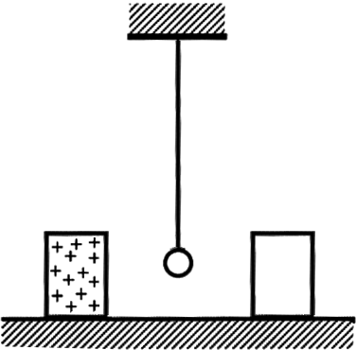

a) Sketch a series of diagrams in which you show

(i) how the uncharged pith ball initially becomes attracted to the charged can

(ii) what happens when it makes contact with the charged can

(iii) why it swings over to the other can and what happens when it makes contact there

(iv) why it continues to swing back and forth.

Accompany each of your diagrams with an explanation of what is happening.

b) Will the back and forth oscillation continue or stop? What is the criterion for its stopping?

