UNIT 16 PRETEST

1) A disk with a red and green block attached to it is spinning at constant angular acceleration.

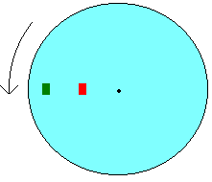

a) Is there a net force on the green block? Explain.

b) Is there a net torque on the red block? Explain.

c) Is there a net torque on the disk? Explain.

