UNIT 14 PRETEST

1) An object of mass m is hung on a spring, as in the picture below. The object is pulled down 0.07m and released. The mass oscillates up and down.

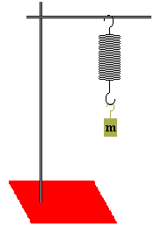

a) If the same experiment were done with a second object of mass 2m, would it oscillate with the same period (the time it takes for the mass to repeat its motion)? Explain.

b) What are possible factors that effect the period of oscillation? Explain.

