UNIT 12 PRETEST

1) The diagram below shows two pulses on a string at time t = 0.

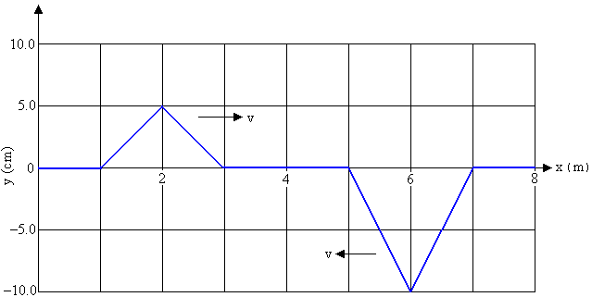

The pulses are moving toward each other. The speed of each pulse is v = 2.0m/s, as shown in the diagram. Sketch the shape of the string 1.0s later in the graph below.

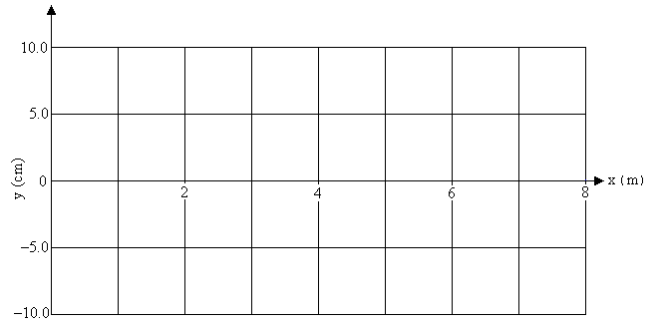

2) A laser beam is shown through two very narrow slits 0.0001m apart on to a wall 4m away. What does the pattern on the wall look like? Explain your reasoning.

