PHYS 1403
Pretest 6

1) A weight lifter is lifting a dumbbell that weighs 75.0 lbs. The biceps muscle exerts a force F_{M} upward on the forearm at a point 2in. from the elbow joint, as shown in the picture below. The weight of the forearm is approximately 15lb. and its center of gravity is 7.30in. from the elbow joint. The upper arm exerts a force F_{J} at the elbow joint. The dumbbell is located 14.5in. from the elbow joint.

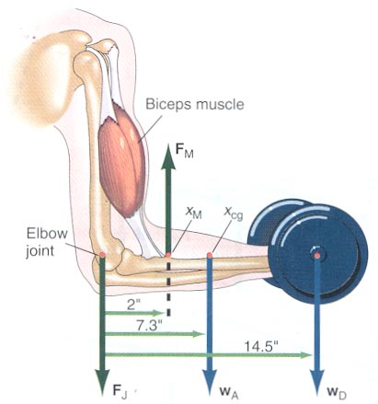

(from Peter J. Nolam, Fundamentals of College Physics, Willaim C. Brown Publishers, Chicago, 1995.)

a) What force must be exerted by the biceps muscle in order to lift the dumbbell? Show your work and explain your reasoning.

b) What is the magnitude of the force F_{J} exerted by the elbow joint? Show your work and explain your reasoning.

