PHYS 1403
Pretest 5

1) A small ball is hung from a spring scale and a reading taken. Then the ball, still attached to the scale, is lowered into a beaker of water, not touching the bottom of the beaker, as in the picture below.

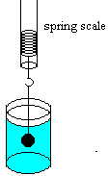

a) Would the reading on the spring scale change? If so, would it increase or decrease? If not, why not? Explain your reasoning.

b) If the ball were lowered so that it touched the bottom of the beaker, still attached to the spring, would the scale reading increase, decrease or remain the same when compared to the reading in part a (lowered into the water, but not touching the bottom)?

