PHYS 1403
Pretest 2

1) Describe the force you would apply to an object on a very low friction track to produce the following velocity vs. time graph. Include the direction of the force and whether it is changing (for example, increasing or decreasing), constant, or anything else relevant to the motion. Explain your reasoning.

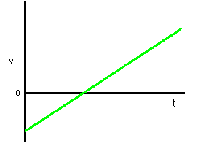

2) Describe the force you would apply to an object on a very low friction track to produce the following acceleration vs. time graph. Include the direction of the force and whether it is changing (for example, increasing or decreasing), constant, or anything else relevant to the motion. Explain your reasoning.

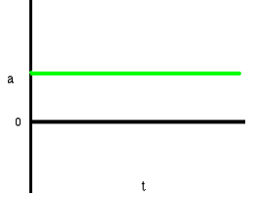

4) A 0.01kg ball is moving in the +x-direction with a constant velocity of +10m/s. When it is at position x = +2.5cm, a constant force is applied opposite to the direction of motion. After the force has been applied for t = 0.02s, the ball is again at x = 2.5cm and the force is stopped.

a) Determine the magnitude and direction of the applied force. Show your work. Explain your reasoning.

b) Draw an appropriate velocity vs. time graph for the motion. Draw an appropriate acceleration vs. time graph for the motion. Explain why you drew the graphs the way you did.

