Pretest 1
PHYS 1306

1) Each of the graphs below is a graph of the position of an object (x) vs. time (t). To the right of each graph, describe how you would walk in order to produce the position vs. time graph. Discuss your starting position, your speed or your acceleration or anything else significant to describing the motion.

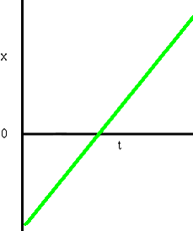

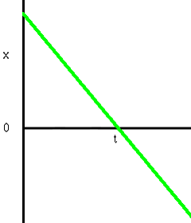
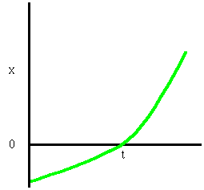

2) Each of the graphs below is a graph of the speed of an object (s) vs. time (t). To the right of each graph, describe how you would walk in order to produce the speed vs. time graph. Discuss your starting position, your speed or your acceleration or anything else significant to describing the motion. If possible, draw a corresponding position vs. time graph or a corresponding acceleration vs. time graph.

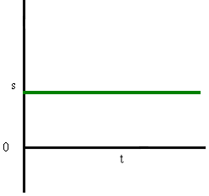

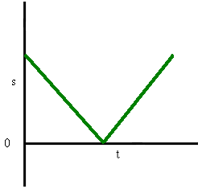
3) Each of the graphs below is a graph of the velocity of an object (v) vs. time (t). For each of the graphs below, describe how you would walk in order to produce the velocity vs. time graph. Discuss your starting position, your speed or your acceleration or anything else significant to describing the motion.

