PHYS 1306
Exam 2

1) A Boeing 747 jet airplane takes off from Dallas to New York. It is cruising at a constant speed of 245km/hr at 11,000m (1km = 1000m). The coefficient of static friction between the airplane seat and a person is 0.28.

a) The airplane makes a level turn of radius 2.0km at constant speed (245km/hr). Would a 60kg person slide off of the seat? Would a 25kg person slide off the seat? Does whether or not a person slides off the seat depend on the person’s mass? Show your work. Explain your reasoning.

b) Would a person slide off of the seat, if the speed of the airplane were lower than 245km/hr? Higher? If it were 500km/hr? Does whether or not a person slides off the seat depend on the speed of the airplane? Explain. If the airplane were making a left turn and there is a speed at which you would slide in your seat, which direction would you slide? Explain.
2) A mechanic pushes a 2500kg car, moving it from rest and making it accelerate from rest to a speed v. He does 5000J of work in the process. During this time the car moves 25.0m.

a) If friction between the car and the road is negligible, what is the final speed of the car? Show your work.

b) If friction is not negligible and the mechanic does the same amount of work, the final velocity is 1.8m/s. How much work is done by the frictional force? Show your work.
3) Tarzan is on a cliff and needs to swing across a river to save Jane. He starts from rest at a height h = 10m above the lowest point of the swing, swinging in a circular path from a 30m long vine (L = 30m), as in the picture below. The vine will break if the tensile force is greater than 1600N. Tarzan’s mass is 90kg.

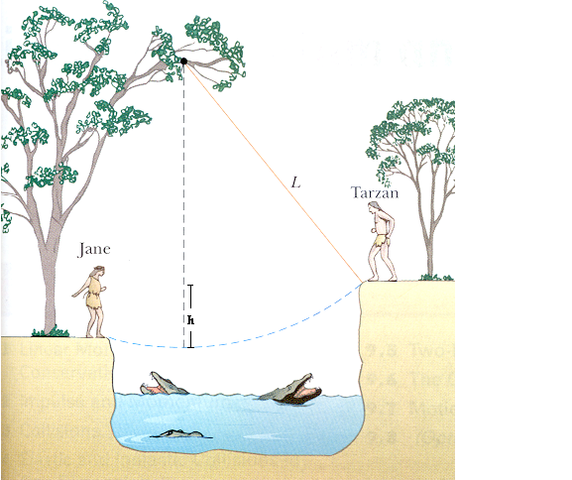

a) What is Tarzan’s speed at the lowest point of the swing? Show your work.

b) Will the vine break at the lowest point of the swing? Show your work. Explain your reasoning.
4) Consider the diagram below.

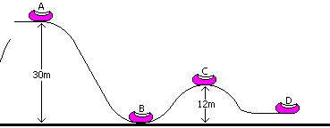

The roller coaster and its screaming occupants have an initial velocity of 25m/s at point A. Assuming no friction, calculate the speed of the coaster at points B and C. Show your work.

