PHYS 1306
Exam 1

1) You and your friends are standing on top of a cliff overlooking a lake when you notice an innertube floating in the water below. A friend challenges you to throw a rock through the center of the innertube. The rock leaves your hand at a point 15m above the surface of the water directly above the base of the cliff. The initial velocity of the rock is 30m/s at an angle of 60º below the horizontal. The center of the innertube is 8m from the base of the cliff and has an inner radius of 0.5m. Does your rock go through the center of the inner tube? Show your work.

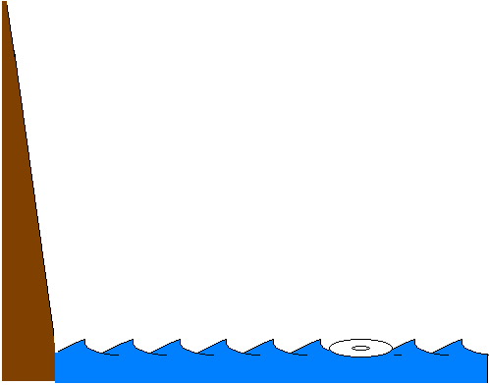
2) A 0.050kg beach ball is dropped from a roof 20.0m above the ground and hits the ground with a speed of 16.8m/s.

a) Draw a force diagram for the ball.

b) Determine if air resistance is negligible. Show your work and explain your reasoning.

c) If air resistance is not negligible, determine the average force of air resistance. If air resistance is negligible, skip this part. Show your work.

3) A 0.050kg low friction cart is moving in the +x-direction with a constant velocity of +10m/s. Friction is negligible. When it is at position x = 2.5m, a constant force is applied opposite to the direction of motion. After the force has been applied for t = 2.0s, the cart is again at x = 2.5m and the force is stopped.

a) Describe the motion of the cart while the force is being applied.

b) Determine the magnitude and direction of the applied force. Show your work. Explain your reasoning.

4) Draw appropriate position vs. time, velocity vs. time and acceleration vs. time graphs for the motion of the cart in problem 3 for the period of time for 2 seconds before the force was applied until 2 seconds after the force was applied. The graphs should have appropriate numerical values on the axes, so that you could read the value of the position, velocity or acceleration of the cart at a particular time off the graph. Explain the relationship between your position graph and your velocity graph (how they are consistent with each other). Explain the relationship between your velocity graph and your acceleration graph (how they are consistent with each other).

