UNIT 4 READING A

Consider an object hung by a string, as in the diagram below.

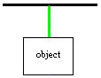

A force diagram for the string is shown in the diagram below.

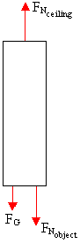

There are three forces acting on the string, the normal force of the ceiling on the string, the normal force of the object on the string, and the gravitational force of the earth on the string. If the mass of the string is negligible, then the gravitational force is practically zero, and the magnitude of the normal force of the ceiling on the string is equal to the magnitude of the normal force of the object on the string.

If we consider the forces acting on a small piece of the string, the forces would be drawn as in the force diagram below.

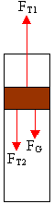

F_{T2} is the force of the lower part of the string on that part of the string, F_{T1} is the force of the upper part of the string on that part of the string, and F_{G} is the gravitational force on that part of the string. If the mass of the string is negligible, then the gravitational force is practically zero, and F_{T1} is equal to F_{T2}. F_{T1} and F_{T2} are called tensile forces. A tensile force is a contact force. For each part of the string, the tensile forces are equal in magnitude, as in the diagram below. We say that the tensile force is transmitted through the string.

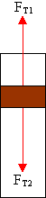

Consider the part of the string at the very top of the string, touching the ceiling. The force diagram for that part is shown below, where the gravitational force is not shown, since it is negligible.

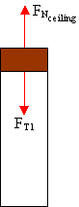

From this diagram, we can see that the magnitude of the force of the ceiling on the string is equal to the magnitude of the tensile force in the string. Similarly, the magnitude of the force of the object on the string can be shown to be equal to the magnitude of the tensile force in the string.

