UNIT 2 READING A

Problem solving

Problem solving is not easy. It is hard. It will not be easy to solve physics problems. You will not be able to look at a sample solution of a problem and use it to solve other problems, unless you understand the physics concepts relevant to the problem. The University of Minnesota Physics Education Research Group has devised a problem solving strategy to help students solve physics problems. Their problem solving strategy is given below:

A Logical Problem Solving Strategy

Introduction
At one level, problem solving is just that, solving problems. Presented with a problem you try to solve it. If you have seen the problem before and you already know its solution, you can solve the problem by recall. Much of the time, however, you have never experienced this situation before (if you had, you would not call it a problem). Solving real problems involves making a logical chain of decisions that lead from an unclear situation to a solution. Solving physics problems is not very different from solving any kind of problem. In your professional life, you will encounter new and complex problems (after all, if your employers knew how to solve these problems, why would they pay you?). The skillful problem solver is able to invent good solutions for these new problem
situations. But how does the skillful problem solver create a solution to a new problem? And how do you learn to be a more skillful problem solver?

A Logical Problem-Solving Strategy
The problem-solving strategy presented here is based on research done in a variety of disciplines such as physics, medical diagnosis, engineering, project design and computer programming. There are many similarities in the way experts in these disciples solve problems. The most important result is that experts follow a general strategy for solving all complex problems. That is, experts solve real problems in several steps. Getting started is the most difficult step. In the first and most important step, you must accurately visualize the situation, identify the actual problem, and identify information relevant to the problem. At first you must deal primarily with the qualitative aspects of the situation. You must interpret the problem in light of your own knowledge and experience. This enables you to decide what information is important, what information can be ignored, and what additional information may be needed, even though it was not explicitly provided. In this step drawing a useful picture of the problem situation is crucial to getting started correctly. A picture is worth a thousand words (if it is the right picture).

In the second step, you must represent the problem in terms of formal concepts and principles, whether these are concepts of engineering design, concepts of medicine, or concepts of physics. These formal concepts and principles use the accumulated knowledge of your field and thus enable you to simplify a complex problem to its essential parts. Frequently, your field has developed a formalized way to diagram the situation which helps show how the concepts are usually applied to a problem. Third, you must use your representation of the problem to plan a solution. Planning results in an outline of the logical steps required to obtain a solution. In many cases the logical steps are conveniently expressed as mathematics. Fourth, you must determine a solution by actually executing the logical steps outlined in your plan. Finally, you must evaluate
how well the solution resolves the original problem.

The general strategy can be summarized in terms of five steps:

(1) Comprehend the problem.
(2) Represent the problem in formal terms.
(3) Plan a solution.
(4) Execute the plan.
(5) Interpret and evaluate the solution.

The strategy begins with the qualitative aspects of a problem and progresses toward the quantitative aspects of a problem. Each step uses information gathered in the previous step to translate the problem into more quantitative terms and to clarify the decisions that you must make. These steps should make sense to you. You have probably used a similar strategy, without thinking about it, when you have solved problems before.

The Importance of Writing
Solving a problem requires that you constantly make decisions. This is very difficult to do if you must also remember many pieces of information and the relationships between those pieces of information. Soon you overload your brain which
has only a small number of short term memory locations. You could forget important parts of the problem or the steps in a mathematical procedure. The chain of decisions you construct may even have logical flaws. Drawing pictures and diagrams and writing your procedures using words, symbols, and mathematics makes the paper a part of your
extended memory. Your brain is then free to deal with the decision-making process. The single biggest mistake of novice problem solvers is not writing down enough in a form that is organized to be a useful aid to their memory. If you have had the experience of understanding how to solve a problem when someone shows you how but “getting lost” when you try to do a similar problem yourself, the effective use of writing could be your
primary trouble.

A Physics-Specific Strategy
Each profession has its own specialized knowledge and patterns of thought. The
knowledge and thought processes that you use in each of the steps will depend on the discipline in which you operate. Taking into account the specific nature of physics, we choose to label and interpret the five steps of the general problem solving strategy as follows:

1. Focus the Problem: In this step you develop a qualitative description of the problem. First, visualize the events described in the problem using a sketch. Write down a simple statement of what you want to find out. Write down the physics ideas that might be useful in the problem and describe the approach you will use. When you finish this step, you should never have to refer to the problem statement again.

2. Describe the Physics: In this step you use your qualitative understanding of the problem to prepare for a quantitative solution. First, simplify the problem situation by describing it with a diagram in terms of simple physical objects and essential physical quantities. Restate what you want to find by naming specific mathematical quantities. Using the physics ideas assembled in step 1, write down equations that specify how these physical quantities are related according to the principles of physics or mathematics. The results of this step contain all of the relevant information so you should not need to refer to step 1 again.

3. Plan the Solution: In this step you translate the physics description into a set of equations that represent the problem mathematically by using the equations assembled in step 2. Each equation should have a specific goal to find a single unknown quantity in the problem. An equation thus used may involve a new unknown quantity that must be determined using another equation. In other words, solving the original problem usually involves creating and solving sub-problems. As you do the mathematical operations to isolate your unknown quantities, you create an outline of how to arrive at a solution. You will find that most of your effort will go into deciding how to construct this logical chain of equations with less effort spent on mathematical operations.

4. Execute the Plan: In this step you actually execute the solution you have planned. Plug in all of the known quantities into the algebraic solution, which is the result of step 3, to determine a numerical value for the desired unknown quantity(ies).

5. Evaluate the Answer: Finally, check your work to see that it is properly stated, not
unreasonable, and actually answers the question asked.

Consider each step as a translation of the previous step into a slightly different language. You begin with the full complexity of real objects interacting in the real world and through a series of decisions arrive at a simple and precise mathematical expression.

The solution to the following problem illustrates each step. On the right side of the page is the actual solution, as you might construct it. On the left side of the page are brief descriptions of each step of the solution. We have used a familiar situation so that you can concentrate on understanding how the strategy is applied.

Problem Solving Strategy
Focus the Problem
Describe the Physics
Plan the Solution
Execute the Plan
Evaluate the Answer
Problem Statement

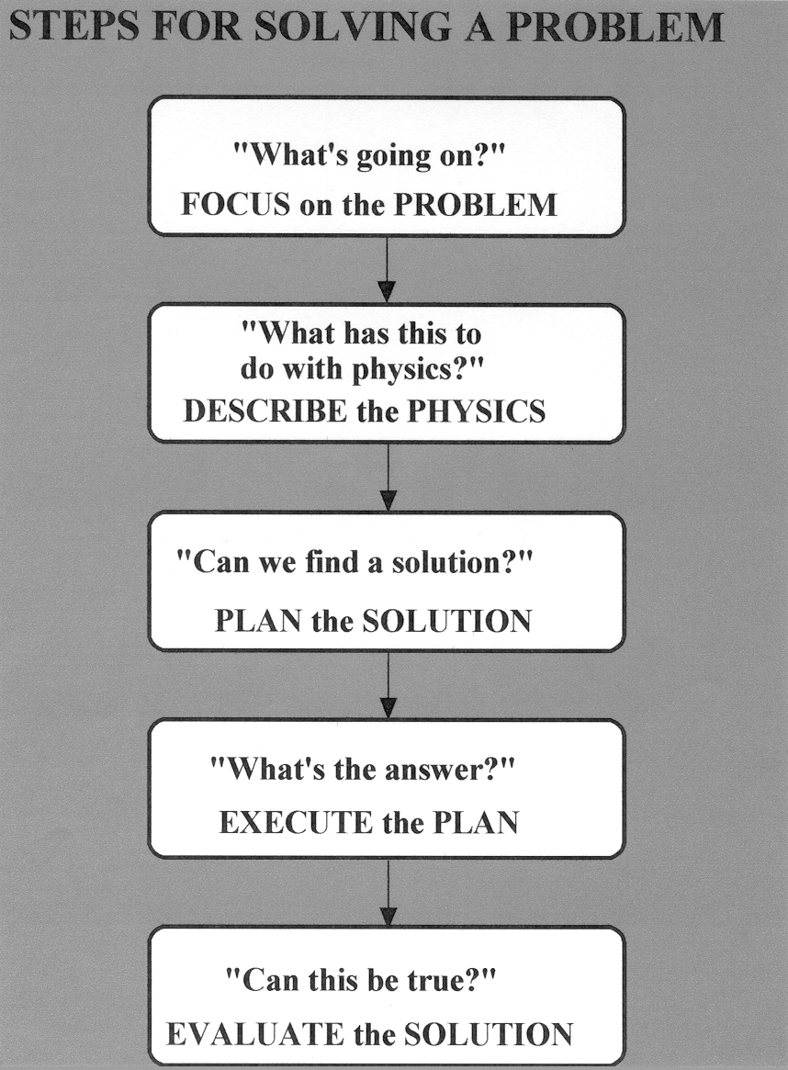

Example of a problem using the problem solving strategy:

A basketball referee tosses the ball straight up for the starting tipoff.

a) At what velocity must a basketball player leave the ground to rise 1.0m above the floor
in an attempt to get the ball?

b) If the floor exerts a constant force on the 110kg basketball player for 0.26 seconds while he pushes off the floor, what is the magnitude of the force of the floor on the basketball player.

Part (a):

(1) Focus on the Problem: What’s going on?

A basketball player leaves the ground and rises one meter. We want to find the initial velocity of the basketball player just after his feet leave the ground.

(2) Describe the Physics: What is the physics?

We know that his acceleration, while he is in the air, if we choose up to be the positive direction is -9.8m/s². We know that his final position is one meter above the ground, his initial position is on the ground, his acceleration is -9.8m/s² and his final velocity is 0:

$\begin{aligned}x_{f}=1m \\ x_{i}=0m \\ v_{f}=0m/s \\ a=−9\text{.}8m/s^{2}\end{aligned}$

taking the zero of position to be at ground level.

(3) Plan the Solution: Can we find the solution?

We can use one of the kinematics equations and the information given to solve the problem:

$$2\bar{a}\left(x_{f}{\text{- x}}_{i}\right)=v_{f}^{2}−v_{i}^{2}$$

(4) Execute the Plan: What is the answer?

Solving for the initial velocity:

$$\begin{aligned}2\bar{a}\left(x_{f}{\text{- x}}_{i}\right)=v_{f}^{2}−v_{i}^{2} \\ v_{i}^{2}=v_{f}^{2}−2\bar{a}\left(x_{f}{\text{- x}}_{i}\right) \\ v_{i}=\sqrt{v_{f}^{2}−2\bar{a}\left(x_{f}{\text{- x}}_{i}\right)} \\ v_{i}=\sqrt{0−2(−9\text{.}8m/s^{2})\left(1\text{.}0m\text{- 0}\right)} \\ v_{i}=4\text{.}4m/s\end{aligned}$$

The initial velocity should be upwards, so it should be positive, so we take the positive value of the square root.

5) Evaluate the Answer: Can this be true?

The units are correct. The velocity is reasonable.

Part (b):

(1) Focus on the Problem: What’s going on?

While the player is pushing off the floor, there are two forces acting on him –- the force of the floor upwards and the gravitational force downwards. The net force on the player upwards is accelerating him from an initial velocity of zero to the velocity of 4.4 m/s with which he leaves the floor.

(2) Describe the Physics: What is the physics?

A force diagram for the person while he is in contact with the floor would look like:

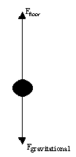

Newton’s second law applied to this situation is:

Where F_{floor} is a positive number, F_{gravitational} is a negative number and the acceleration is positive.

We know the magnitude of the gravitational force F_{gravitational} = mg, where m is the mass of the basketball player and g = 9.8m/s². If we knew the acceleration, we could find the force of the floor.

We know the force of the floor is applied for a time interval of 0.26s. We could use one of the kinematics equations to find the average acceleration of the basketball player while he is in contact with the floor. Then we could use Newton's Second Law to find the force of the floor on the player.

To find the average acceleration of the basketball player while he is in contact with the floor, we could use one of the kinematics equations and the following information:
$$\begin{aligned}v_{i}=0m/s \\ v_{f}=4\text{.}4m/s \\ t=0\text{.}\text{26}s\end{aligned}$$

(3) Plan the Solution: Can we find the solution?

We can use the definition of average acceleration and the information above, to solve for the average acceleration:

Then we can use Newton’s second law to solve for the force of the floor:

(4) Execute the Plan: What is the answer?

Find the average acceleration:

$$\begin{aligned}\bar{a}=\frac{v_{f}−v_{i}}{t} \\ \bar{a}=\frac{4\text{.}4m/s−0m/s}{0\text{.}\text{26}s} \\ \bar{a}=\text{16}\text{.}9m/s^{2}\end{aligned}$$

Find the force of the floor:

(5) Evaluate the Answer: Can this be true?

The gravitational force on the basketball player is:

The force of floor upward is greater than the gravitational force, which makes sense because the net force and the acceleration are upwards.

