UNIT 1 READING A

Position

It is often convenient to draw a numbered line or a two or more dimensional grid with numbers on it to describe the position of an object.

Below are two different ways to place a numbered line to determine the position of the green dot.

In the first diagram, the position of the green dot is x = 5cm.

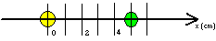

In the second diagram, the position of the green dot is at x = 3cm.

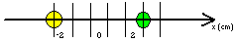

When we draw a numbered line, we choose where to put the origin of the numbered line. The position depends on where we choose to put the origin.

The position of an object in two dimensions is found by laying down a grid with numbers on it in two directions.

Below are two different ways to place a grid to determine the position of the green dot:

In the first diagram, the position of the green dot is x = 6cm and y = 0cm.

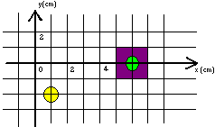

In the second diagram, the position of the green dot is at x = 2cm, y = 2cm.

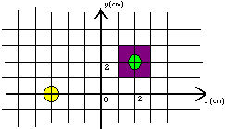

When we draw a grid, we choose where to put the origin of the grid. The position depends on where we choose to put the origin of the grid. We could represent the position of an object by an arrow from the origin of the grid to the location of the object. The position of an object at x = 7cm, y = 4cm is shown in the diagram below. It has a length of 8 cm and a direction 29.7° above the +x-axis.

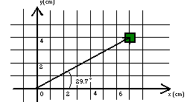

A quantity that can be represented by an arrow is called a vector. In order to describe an arrow, both the length of the arrow and the direction of the arrow must be given. The length of the vector (arrow) is called the magnitude of the vector. When a quantity can be represented by a vector, it is symbolized by a bold character. The position of the green dot in the diagram below, is called x.

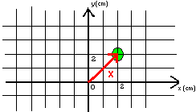

Displacement

Consider an object that moves from one point to another. The displacement is a vector quantity that represents the distance the object moves in a particular direction. The magnitude of the displacement vector is the distance moved. Mathematically, the displacement is defined as the difference of the final position and the initial position of the object, the difference between two vectors.

Consider an object moving in one dimension (an object moving in a straight line). If the initial position of the object is at 5cm, it can be represented by the vector x_{i} shown in the diagram below.

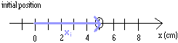

If the final position of the object is at 7cm, the final position can be represented by the vector x_{f} shown in the diagram below.

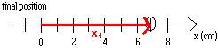

The displacement is an arrow representing the distance the object has moved in a particular direction. In this example, the displacement is an arrow 2cm long to the right, as shown in the diagram below.

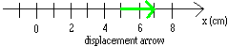

The displacement is the distance an object moves in a particular direction.

If the object had moved from x = 5cm to x = 3cm, the initial and final position vectors would be represented as in the diagrams below

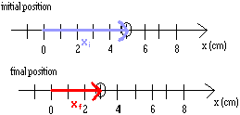

and the displacement would be represented by an arrow in the –x-direction.

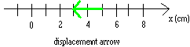

If an object moves from x = 4cm, y = 2cm to x = 2cm, y = 5cm, the arrows representing the initial position, the final position and the displacement are shown in the pictures below.

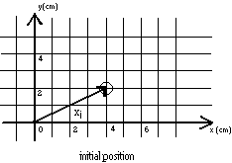
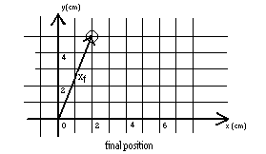

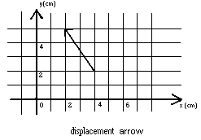

Mathematically, the displacement is the difference in two vectors, $x_{f}−x_{i}$, which can be found by vector subtraction. Vector subtraction will be discussed in the next section. We often use the symbol delta, Δ, to indicate the difference between two quantities. The symbol delta, Δ, preceding a quantity means a change in that quantity. The displacement, for example, can be symbolized by $Δx$, where$Δx=x_{f}−x_{i}$.

