Homework 5
PHYS 1403
due February 26, 2004

Homework should be written out neatly on a separate sheet of paper. Explain your reasoning.

1) Boxes I, II and III are touching each other. A force, F, is applied to box III, as in the diagram below.

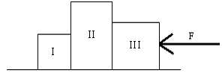

Draw a force diagram for each of the boxes, including the frictional force (as you did in homework 4). For each force, indicate the Newton’s third Law pair force. Explain your reasoning.

2) Two boxes are hanging from ropes, as in the diagram below. The mass of box 1 is
m₁ = 2.00kg and the mass of box 2 is m₂ = 1.51kg.

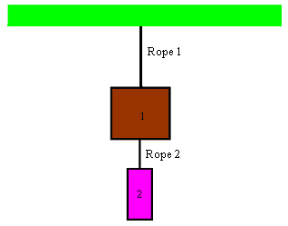

a) Draw a force diagram for each of the boxes.

b) Determine the tensile force in each of the ropes? Show your work. Explain your reasoning

3) A bricklayer is on a platform attached to one end of a rope and the other end of the rope goes over a pulley and is attached to a bucket of bricks, as illustrated in the diagram below.

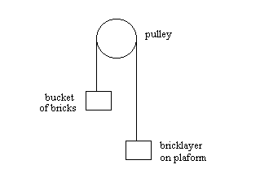

a) Consider the bricklayer plus platform to be one object. Draw a force diagram for the bricklayer + platform and for the bucket of bricks.

b) If the bricklayer + platform has more mass than the bucket of bricks, what will happen? If the bucket of bricks has more mass than the bricklayer, what will happen? In each case, do the bricks and the bricklayer accelerate at the same rate? Explain your reasoning. Do either or both the bricklayer + platform and bucket of bricks accelerate at 9.8m/s²? Explain your reasoning.

c) If the mass of the bucket of bricks is 67.0kg and the mass of the bricklayer + platform is three times the mass of the bucket of bricks, determine the acceleration of the bricklayer + platform. Show your work and explain your reasoning.

The Bricklayer’s Song
Dear sir, I write this note to you to tell you of my plight,
For at the time of writing it I’m not a pretty sight;
My body is all black and blue, my face a deathly gray,
And I write this note to say why I am not at work today.
While working on the 14th floor, some bricks I had to clear,
But tossing them down from such a height was not a good idea.
The foreman wasn’t very pleased; he is a rigid hack
And he said I had to cart them down the ladder on my back.
Well, clearing all these bricks by hand – it was so very slow,
So I hoisted up a barrel and secured a rope below.
But in me haste to do the job, I was too blind to see
That a barrel full of building bricks was heavier than me.
And so when I untied the rope the barrel fell like lead,
And clinging tightly to the rope, I started up instead.
I shot up like a rocket and to my dismay I found
That halfway up I met the bloody barrel coming down.
Well, the barrel broke me shoulder as to the ground it sped,
And when I reached the top I banged the pulley with me head.
But I clung on tightly, numb with shock, from this almighty blow,
While the barrel spilled out half its bricks, some 14 floors below.
Now when these bricks had fallen from the barrel to the floor
I then outweighed the barrel, and so started down once more.
But I clung on tightly to the rope, me body racked with pain
And half way down I met the bloody barrel once again.
The force of this collision half way down the office block
Caused multiple abrasions and a nasty case of shock,
But I clung on tightly to the rope as I fell towards the ground,
And I landed on the broken bricks the barrel scattered ‘round.
Well as I lay there on the floor I thought I’d passed the worst,
But the barrel hit the pulley wheel and then the bottom burst.
A shower of bricks rained down on me; I didn’t have a hope,
As I lay there bleeding on the ground I let go the bloody rope.
The barrel now being heavier, it started down once more.
It landed right across me as I lay there on the floor.
It broke three ribs and my left arm, and I can only say
I hope you’ll understand why I am not at work today.
Now the moral of my story it is awfully plain to see
That physics is a class that would have been some help to me;
So study all your lessons well and think before you act,
Or you’ll run the risk of suffering from your own mistakes’ impact.
by N. Murphy
arr. ©1995 David & Ginger Hildebrand

