Homework 4
PHYS 1403
due February 19, 2004

Homework should be written out neatly on a separate sheet of paper. Explain your reasoning.

1) Boxes I, II and III are touching each other. A force, F, is applied to box III, as in the diagram below.

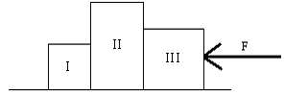

a) Draw a force diagram for each of the boxes, including the frictional force. Label all of the forces.

b) Now assume that the surface is frictionless. The masses of the three boxes are
m_{I}= 20.0kg, m_{II}= 40.0kg, and m_{III}= 25.0kg, for boxes I, II and III respectively. The magnitude of the force is F = 75N. Find the acceleration of the blocks and the magnitudes of the contact forces between the blocks. Show your work.

2) A stunt jumper is attempting to jump over 10 school busses lined up side by side, as indicated in the picture below. Each school bus is 2.74m wide. His velocity as he leaves the takeoff ramp at an angle of 18° is 33m/s. Does he succeed in jumping over the busses? Show your work.

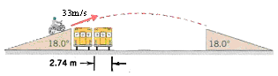

3) Draw a force diagram for each of the books and the table shown in the picture below. Label each of the forces and indicate which object is causing the force.

