Homework 2
PHYS 1403
due February 5, 2004

Homework should be written out neatly on a separate sheet of paper. Explain your reasoning.

1) Find the sum of the two vectors shown in the diagram below. The red vector has a magnitude 60 m and is at a 55 degree angle to the y-axis. The green vector has a magnitude 85 m and is at a 65 degree angle to the –x-axis. Show your work.

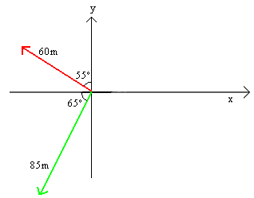

2) Find the sum of the three vectors shown in the diagram below. The red vector has a magnitude 28 m and is at a 31 degree angle to the y-axis. The green vector has a magnitude 58 m and is at a 28 degree angle to the –x-axis. The blue vector has a magnitude 61 m and is at a 57 degree angle to the –x-axis. Show your work.

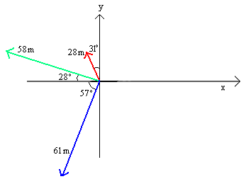

3) A woman drives 3 km north, then 12 km to the northwest, and finally 5 km south-southwest. How far has she traveled? What is her displacement?

