Homework 1
PHYS 1403
due January 29, 2004

Homework should be written out neatly on a separate sheet of paper. Explain your reasoning.

1) For each of the position vs. time graphs below, sketch the corresponding velocity vs. time graph. In your sketch, place the velocity graph directly below the position graph, so that corresponding times match up visually. Explain why you drew the graphs the way you did.
.
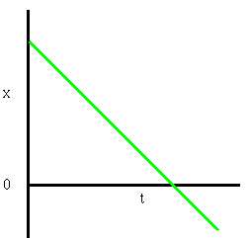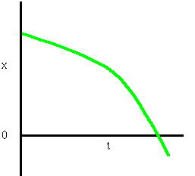

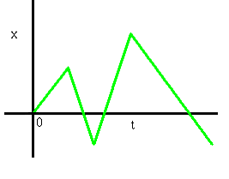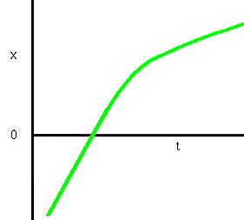

2) For each of the velocity vs. time graphs below, sketch possible corresponding position vs. time and acceleration vs. time graphs. In your sketch, place the position graph directly above the velocity graph and the acceleration graph directly below the velocity graph, so that corresponding times match up visually. Explain why you drew the graphs the way you did.

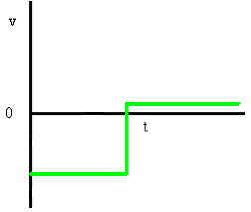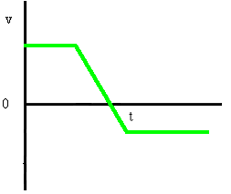

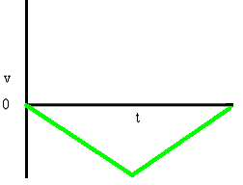

3) For each of the acceleration vs. time graphs below, sketch possible corresponding position vs. time and velocity vs. time graphs. In your sketch, place the position graph directly above the velocity graph and the velocity graph directly above the acceleration graph, so that corresponding times match up visually. Explain why you drew the graphs the way you did.

